**Name : Subject :** Cloud Computing

**Class:** TY BSc ( COMPUTER SCIENCE) **Exam Seat no:**

**Academic Year : Paper II**

|  |  |  |  |  |
| --- | --- | --- | --- | --- |
|  |  | **INDEX** |  |  |
| **No** | **Date** | **TITLE** | **Page No** | **SIGN** |
| 1 |  | To study cloud architecture and cloud computing model. |  |  |
| 2 |  | Installation and Configuration of virtualization using KVM. |  |  |
| 3 |  | Study and implementation of Infrastructure as a Service |  |  |
| 4 |  | Study and implementation of Storage as a Service |  |  |
| 5 |  | Study and implementation of identity management |  |  |
| 6 |  | Study Cloud Security management |  |  |
| 7 |  | Write a program for web feed. |  |  |
| 8 |  | Study and implementation of Single-Sing-On. |  |  |
| 9 |  | User Management in Cloud. |  |  |
| 10 |  | Evaluate the functionality of VDI using Foss Server. |  |  |
| 11 |  | Case study on Amazon EC2/Microsoft Azure/ Google Cloud  Platform. |  |  |

# Practical-1

1. **Aim:**To study cloud architecture and cloud computing model.
2. **Objectives:** From this experiment, the student will be able to
   * provide an overview of concepts of Cloud Computing .
   * To encourage students to indulge into research in Cloud Computing.
3. **Outcomes:** The learner will be able to
   * understand and appreciate cloud architecture.
   * analyze the local and global impact of computing on individuals, organizations, and society.
   * recognize the need for, and an ability to engage in life-long learning.
4. **Hardware / Software Required:**Ubuntu operating system, Internet
5. **Theory:**

Cloud computing enables companies to consume compute resources as a utility -- just like electricity -- rather than having to build and maintain computing infrastructures in-house. Cloud computing promises several attractive benefits for businesses and end users.

Three of the main benefits of cloud computing include:

* [Self-service provisioning](http://searchcloudprovider.techtarget.com/definition/User-self-provisioning): End users can spin up computing resources for almost any type of workload [on-demand.](http://searchdatacenter.techtarget.com/definition/on-demand-computing)
* [Elasticity](http://searchcio.techtarget.com/definition/IT-elasticity): Companies can scale up as computing needs increase and then scale down again as demands decreases.

[Pay per use](http://searchcio.techtarget.com/definition/metered-services): Computing resources are measured at a granular level, allowing users to pay only for the resources and workloads they use.

Cloud computing services can be [Private,](http://searchcloudcomputing.techtarget.com/definition/private-cloud) [Public](http://searchcloudcomputing.techtarget.com/definition/public-cloud) or [Hybrid.](http://searchcloudcomputing.techtarget.com/definition/hybrid-cloud)

Private cloud services are delivered from a business' data center to internal users. This model offers versatility and convenience, while preserving management, control and security. Internal customers may or may not be billed for services through [IT chargeback.](http://searchaws.techtarget.com/definition/IT-chargeback-showback)

In the Public cloud model, a third-party provider delivers the cloud service over the Internet. Public cloud services are sold on-demand, typically by the minute or the hour. Customers only pay for the [CPU](http://whatis.techtarget.com/definition/CPU-central-processing-unit) cycles, [storage](http://searchstorage.techtarget.com/definition/storage) or [bandwidth](http://searchenterprisewan.techtarget.com/definition/bandwidth) they consume. Leading

public cloud providers include Amazon Web Services ([AWS](http://whatis.techtarget.com/definition/Amazon-Web-Services-AWS)), Microsoft [Azure](http://searchwindowsserver.techtarget.com/definition/Microsoft-Azure-Windows-Azure), IBM/SoftLayer and [Google Compute Engine.](http://searchaws.techtarget.com/definition/Google-Compute-Engine)

Hybrid cloud is a combination of public cloud services and on-premises private cloud – with orchestration and automation between the two.

Companies can run mission-critical workloads or sensitive applications on the private cloud while using the public cloud for workloads that must scale on-demand. The goal of hybrid cloud is to create a unified, automated, scalable environment which takes advantage of all that a public cloud infrastructure can provide, while still maintaining control over mission-critical data.

Types of cloud computing:

IT people talk about three different kinds of cloud computing, where different services are being provided for you. Note that there's a certain amount of vagueness about how these things are defined and some overlap between them.

* + Infrastructure as a Service (IaaS) means you're buying access to raw computing hardware over the Net, such as servers or storage. Since you buy what you need and pay-as-you-go, this is often referred to as utility computing. Ordinary web hosting is a simple example of IaaS: you pay a monthly subscription or a per- megabyte/gigabyte fee to have a hosting company serve up files for your website from their servers.
  + Software as a Service (SaaS) means you use a complete application running on someone else's system. Web-based email and Google Documents are perhaps the best-known examples. Zoho is another well-known SaaS provider offering a variety of office applications online.
  + Platform as a Service (PaaS) means you develop applications using Web-based tools so they run on systems software and hardware provided by another company. So, for example, you might develop your own ecommerce website but have the whole thing, including the shopping cart, checkout, and payment mechanism running on a merchant's server. Force.com (from salesforce.com) and the Google App Engine are examples of PaaS.
  + Advantages and disadvantages of cloud computing

Advantages: The pros of cloud computing are obvious and compelling. If your business is selling books or repairing shoes, why get involved in the nitty gritty of buying and maintaining a complex computer system? If you run an insurance office, do you really want your sales agents wasting time running anti-virus software, upgrading word- processors, or worrying about hard-drive crashes? Do you really want them cluttering

your expensive computers with their personal emails, illegally shared [MP3](http://www.explainthatstuff.com/how-mp3players-work.html) files, and naughty YouTube videos—when you could leave that responsibility to someone else? Cloud computing allows you to buy in only the services you want, when you want them, cutting the upfront capital costs of computers and peripherals. You avoid equipment going out of date and other familiar IT problems like ensuring system security and reliability. You can add extra services (or take them away) at a moment's notice as your business needs change. It's really quick and easy to add new applications or services to your business without waiting weeks or months for the new computer (and its software) to arrive.

Disadvantages: Instant convenience comes at a price. Instead of purchasing computers and software, cloud computing means you buy services, so one-off, upfront capital costs become ongoing operating costs instead. That might work out much more expensive in the long-term.

If you're using software as a service (for example, writing a report using an online word processor or sending emails through webmail), you need a reliable, high- speed, [broadband](http://www.explainthatstuff.com/howbroadbandworks.html) Internet connection functioning the whole time you're working. That's something we take for granted in countries such as the United States, but it's much more of an issue in developing countries or rural areas where broadband is unavailable.

If you're buying in services, you can buy only what people are providing, so you may be restricted to off-the-peg solutions rather than ones that precisely meet your needs. Not only that, but you're completely at the mercy of your suppliers if they suddenly decide to stop supporting a product you've come to depend on. (Google, for example, upset many users when it [announced](http://www.zdnet.com/google-apps-axes-export-support-for-doc-and-other-old-microsoft-office-formats-7000004884/) in September 2012 that its cloud-based Google Docs would drop support for old but de facto standard Microsoft Office file formats such as .DOC, .XLS, and .PPT, giving a mere one week's notice of the change— although, after public pressure, it later extended the deadline by three months.) Critics charge that cloud-computing is a return to the bad-old days of mainframes and proprietary systems, where businesses are locked into unsuitable, long-term arrangements with big, inflexible companies. Instead of using "generative" systems (ones that can be added to and extended in exciting ways the developers never envisaged), you're effectively using "dumb terminals" whose uses are severely limited by the supplier. Good for convenience and security, perhaps, but what will you lose in flexibility? And is such a restrained approach good for the future of the Internet as a whole? (To see why it may not be, take a look at Jonathan Zittrain's eloquent book [The](http://futureoftheinternet.org/) [Future of the Internet—And How to Stop It](http://futureoftheinternet.org/).)

### Conclusion:

Cloud computing enables a convenient and on-demand network access to a wide range of resources. The different services and also the deployment models allow flexible service provider interaction with minimal human intervention. It saves costs but also can lead to risk issues and suspension of resources when in huge quantity.

# Practical-2

### Ex 2. Installation and Configuration of virtualization using KVM.

1. **Aim:**Installation and Configuration of virtualization using KVM
2. **Objectives:** From this experiment, the student will be able to,
   * Understand the concepts of virtualization.
   * Understand KVM architecture and its configuration.
3. **Outcomes:** The learner will be able**,**
   * To analyze user models and develop user centric interfaces
   * To analyze the local and global impact of computing on individuals, organizations, and society.
   * To engage in life-long learning development and higher studies.
   * To understand, identify, analyze and design the problem, implement and validate the solution including both hardware and software.
4. **Hardware / Software Required:**Ubuntu operating system, open source software KVM, Internet.

### Theory:

Virtualization is software that separates physical infrastructures to create various dedicated resources. It is the fundamental technology that powers cloud computing. The technology behind virtualization is known as a virtual machine monitor (VMM) or virtual manager, which separates compute environments from the actual physical infrastructure.

Virtualization makes servers, workstations, storage and other systems independent of the physical hardware layer. This is done by installing a Hypervisor on top of the hardware layer, where the systems are then installed.

There are three areas of IT where virtualization is making headroads, network virtualization, storage virtualization and server virtualization:

* Network virtualization is a method of combining the available resources in a network by splitting up the available bandwidth into channels, each of which is independent from the others, and each of which can be assigned (or reassigned) to a particular server or device in real time. The idea is that virtualization disguises

the true complexity of the network by separating it into manageable parts, much like your partitioned hard drive makes it easier to manage your files.

* Storage virtualization is the pooling of physical storage from multiple network storage devices into what appears to be a single storage device that is managed from a central console. Storage virtualization is commonly used in storage area networks (SANs).
* Server virtualization is the masking of server resources (including the number and identity of individual physical servers, processors, and operating systems) from server users. The intention is to spare the user from having to understand and manage complicated details of server resources while increasing resource sharing and utilization and maintaining the capacity to expand later. Virtualization can be viewed as part of an overall trend in enterprise IT that includesautonomic computing, a scenario in which the IT environment will be able to manage itself based on perceived activity, and utility computing, in which computer processing power is seen as a utility that clients can pay for only as needed. The usual goal of virtualization is to centralize administrative tasks while improving scalability and work loads.

### Procedure:

Installation Steps :

1. sudo grep -c "svm\|vmx" /proc/cpuinfo
2. sudo apt-get install qemu-kvm libvirt-bin bridge-utils virt-manager
3. sudo adduser rait
4. sudo adduser rait libvirtd
5. virsh -c qemu:///system list

(Run following command after logging back in as rait and you should see an empty list of virtual machines. This indicates that everything is working correctly.)

1. virt-manager

(Open Virtual Machine Manager application and Create Virtual Machine )

### Result:

SNAPSHOTS

Step 1 : #sudo grep -c "svm\|vmx" /proc/cpuinfo

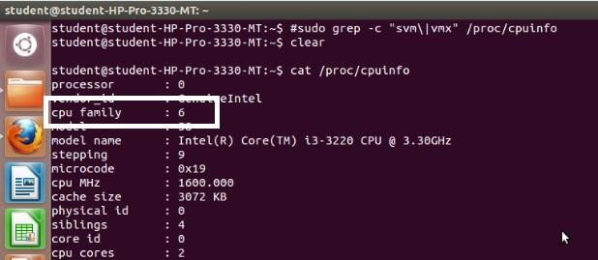

Step 2 : #sudo apt-get install qemu-kvm libvirt-bin bridge-utils virt-manager

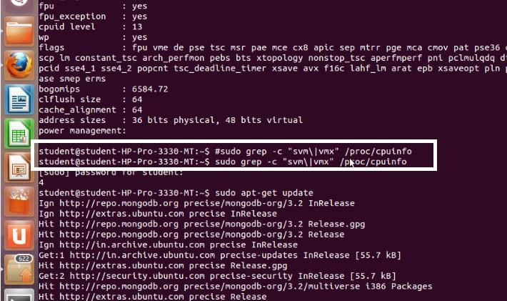

Step 3 : #sudo adduser rait

After running this command, log out and log back in as rait

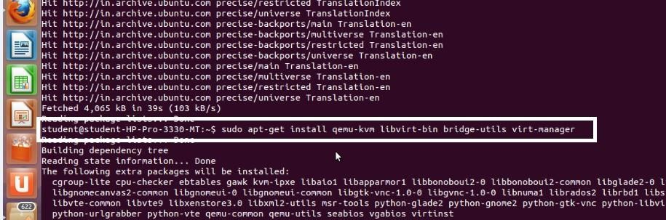

Step 4 : #sudo adduser rait libvirtd

After running this command, log out and log back in as rait

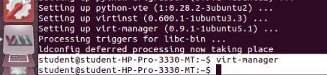

Step 5 : Open Virtual Machine Manager application and Create Virtual Machine #virt-manager as shown below

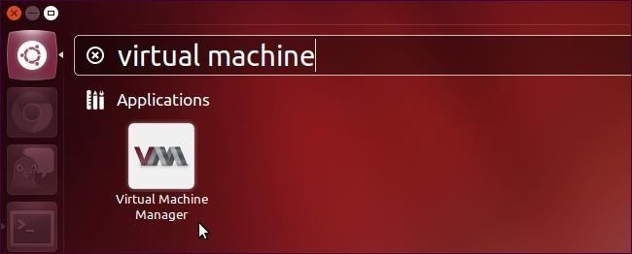

Step 6 : Create a new virtual machine as shown below

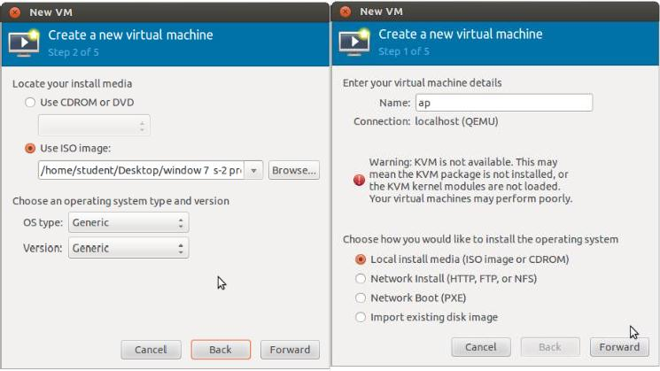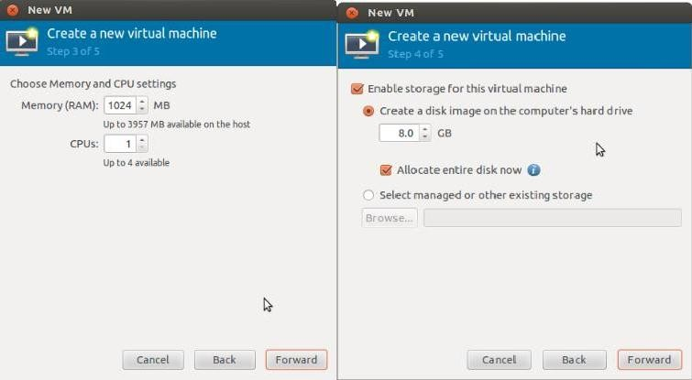

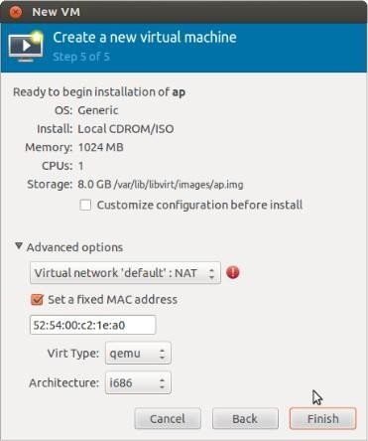

Step 7 : Install windows operating system on virtual machine

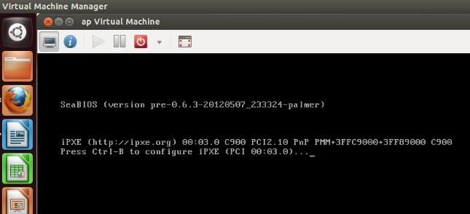

Step 8: Installation of windows on virtual machine

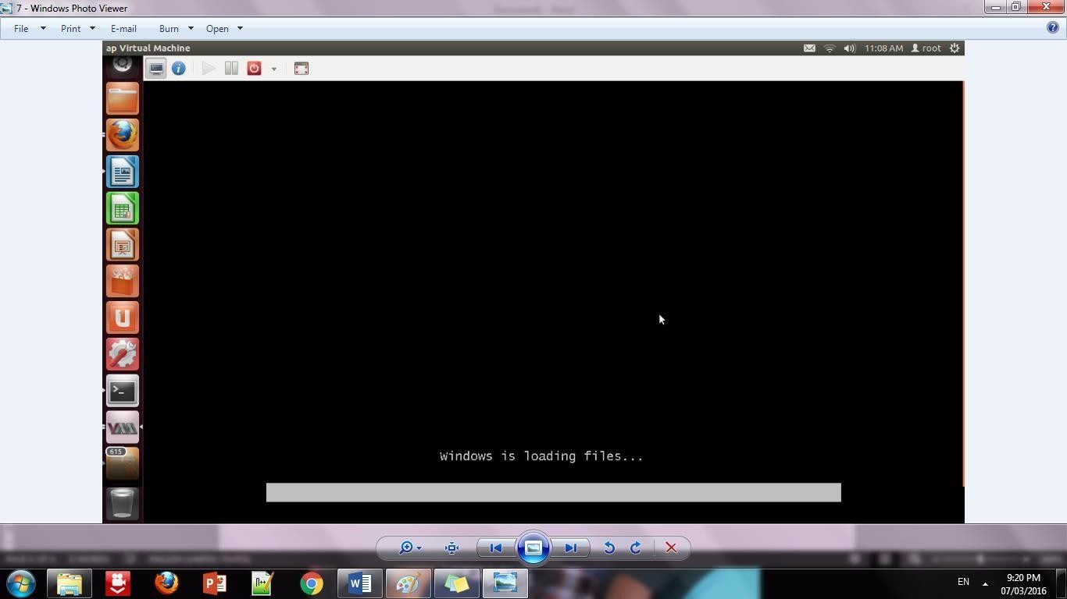

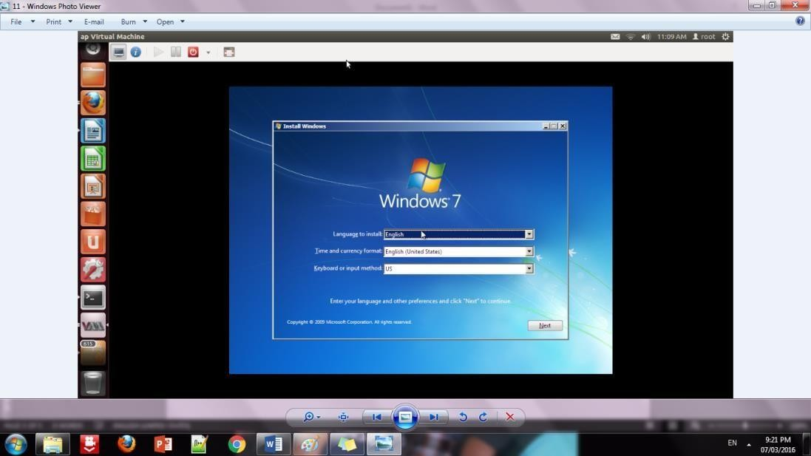Step 9: Installation of windows 7 on virtual machine

Step 10: Initialization of windows on virtual machine

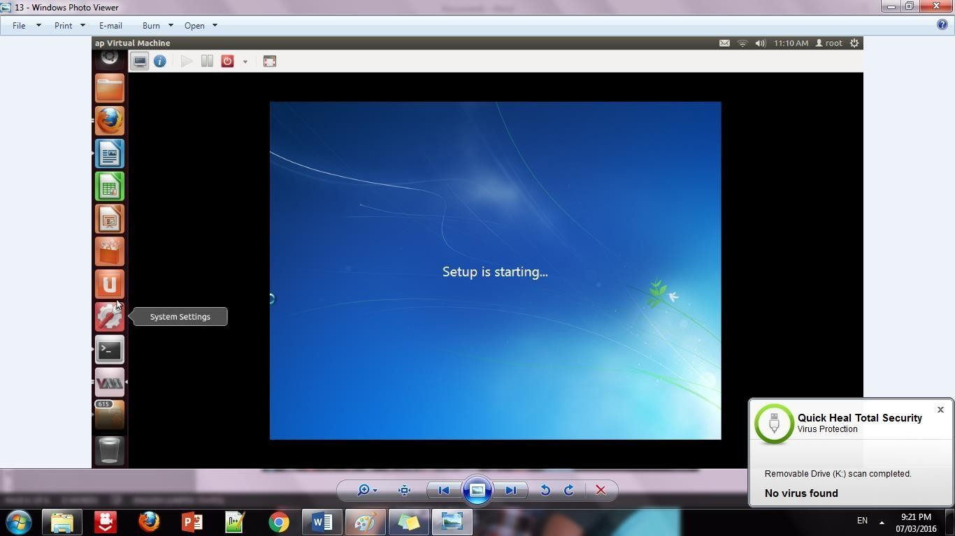

##### Conclusion:

Installation and configuration of KVM have been done successfully onto Ubuntu and users added. Like this we can create as many virtual machines as possible on OS and can install any windows onto it.

# Practical-4

**Aim:** Study and implementation of Storage as a Service.

**Description:**

Storage as a Service is a business model in which a large company rents space in their storage infrastructure to a smaller company or individual.

In the enterprise, SaaS vendors are targeting secondary storage applications by promoting SaaS as a convenient way to manage backups. The key advantage to SaaS in the enterprise is in cost savings -- in personnel, in hardware and in physical storage space. For instance, instead of maintaining a large tape library and arranging to vault (store) tapes offsite, a network administrator that used SaaS for backups could specify what data on the network should be backed up and how often it should be backed up. His company would sign a service level agreement (SLA) whereby the SaaS provider agreed to rent storage space on a cost-per-gigabyte- stored and cost-per-data-transfer basis and the company's data would be automatically transferred at the specified time over the storage provider's proprietary wide area network (WAN) or the Internet. If the company's data ever became corrupt or got lost, the network administrator could contact the SaaS provider and request a copy of the data.

Storage as a Service is generally seen as a good alternative for a small or mid-sized business that lacks the capital budget and/or technical personnel to implement and maintain their own storage infrastructure. SaaS is also being promoted as a way for all businesses to mitigate risks in disaster recovery, provide long-term retention for records and enhance both business continuity and availability.

### Procedure:

##### open chrome->search for google drive

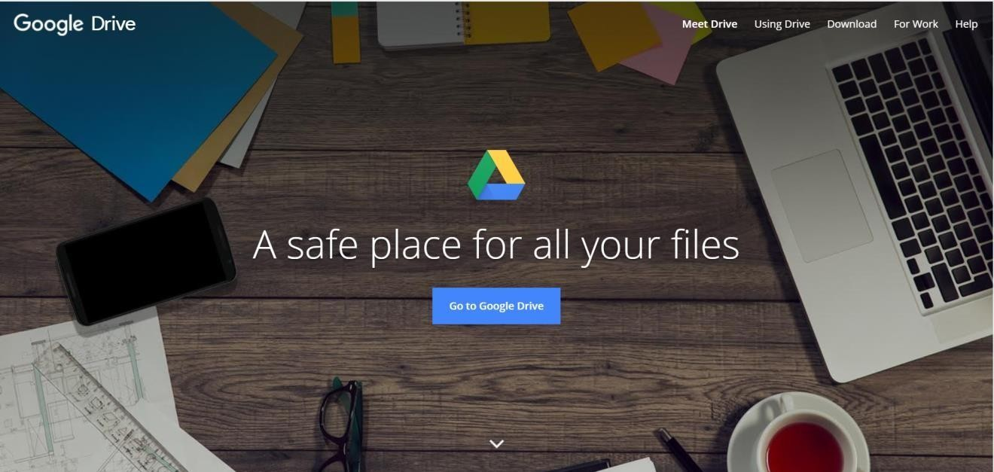

now click on **GO TO DRVIE**

now **sign in** with google account and this interface will appear.

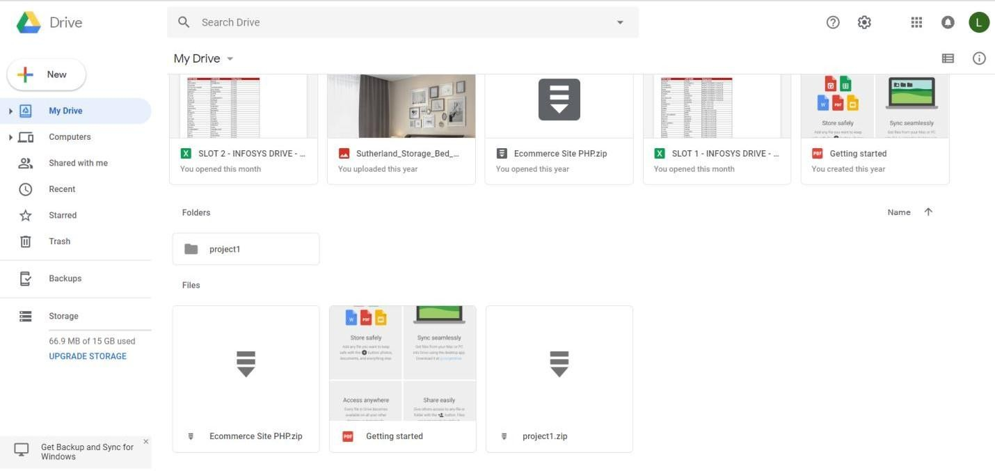

Now click **New** to upload file on drive->select the file that you have to upload from your Computer.

And click on open

If the file is uploaded then it will show successfully uploaded as shown in image

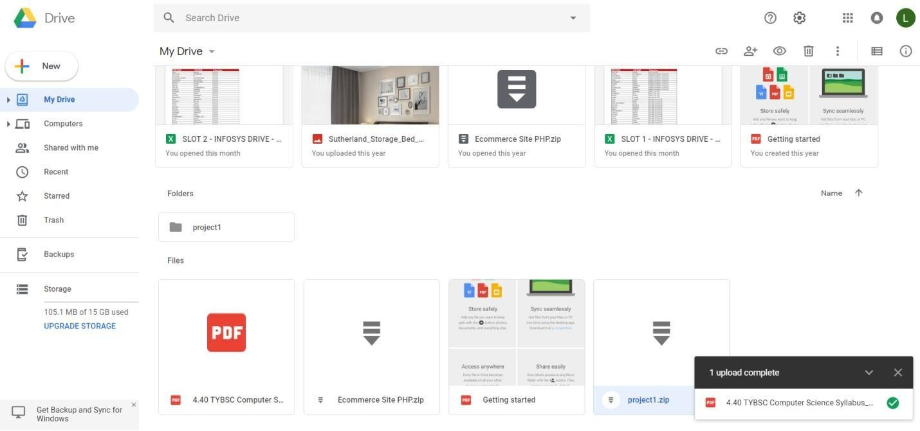

##### Now sharing that file with your friends.

Select that doc which you have uploaded right click on that and click on share

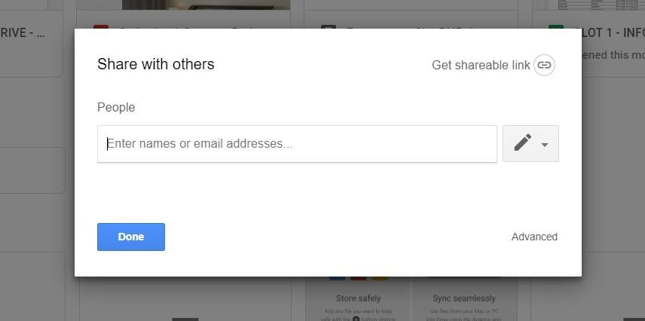

Now enter the email of your friend and provide subject name and click done Your friend will receive the mail as shown in image

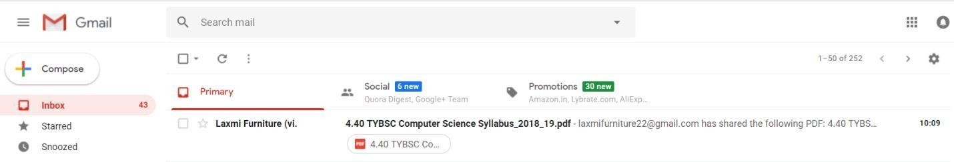

Now click on open that document will open which you have share to your friend.



# Practical 5

### Aim: Study and implementation of Identity Management Description:

Identity management’s primary goal in cloud computing is managing personal identity information so that access to computer resources, applications, data, and services is controlled properly. Identity management is the one area of IT security that offers genuine benefits beyond reducing the risk of security breaches.Identity management helps prevent security breaches and plays a significant role in helping your company meet IT security compliance regulations. The benefits of keeping your customer or company financial data safe from unauthorized access can be huge.

In addition, you reap many benefits from identity management that occurs every day, not just during a major threat.

* **Improved user productivity:** Productivity improvement comes from simplifying the sign- on interface and the ability to quickly change access rights. Productivity is likely to improve further where you provide user self-service.
* **Improved customer and partner service:** Customers and partners also benefit from a more streamlined, secure process when accessing applications and data.
* **Reduced help desk costs:** IT help desks typically experience fewer calls about forgotten passwords when an identity management process is implemented.
* **Reduced IT costs:** Identity management enables automatic provisioning, providing or revoking users’ access rights to systems and applications. Provisioning happens whether you automate it or not.

### Procedure:

**Click on link below.** [**https://aws.amazon.com/console/**](https://aws.amazon.com/console/)

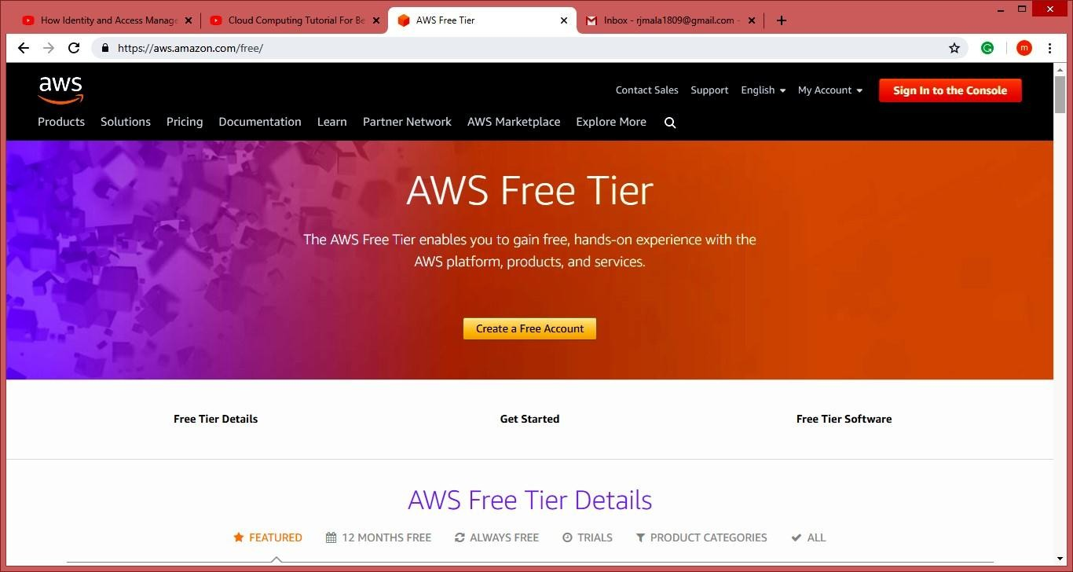

**Go to “My Account” > “AWS Management Console”.**

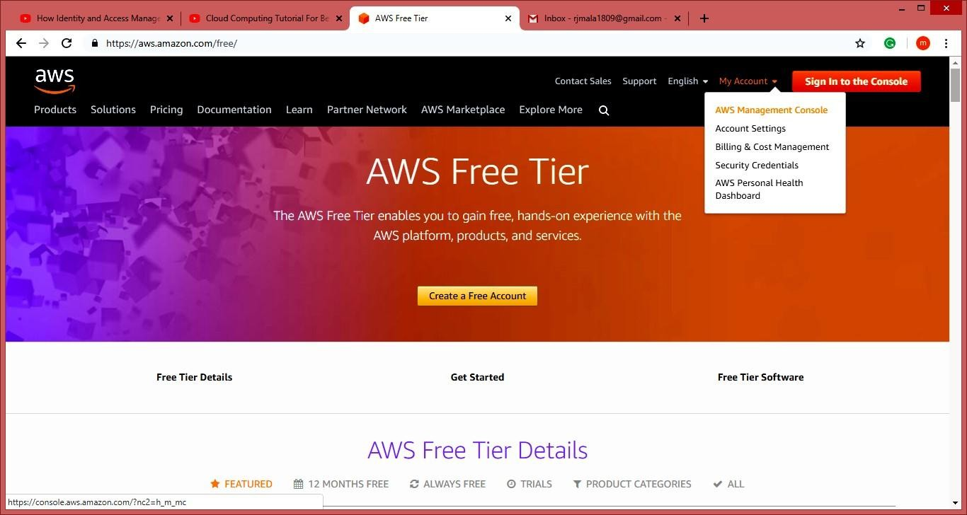

##### Create AWS account(fill the required details)

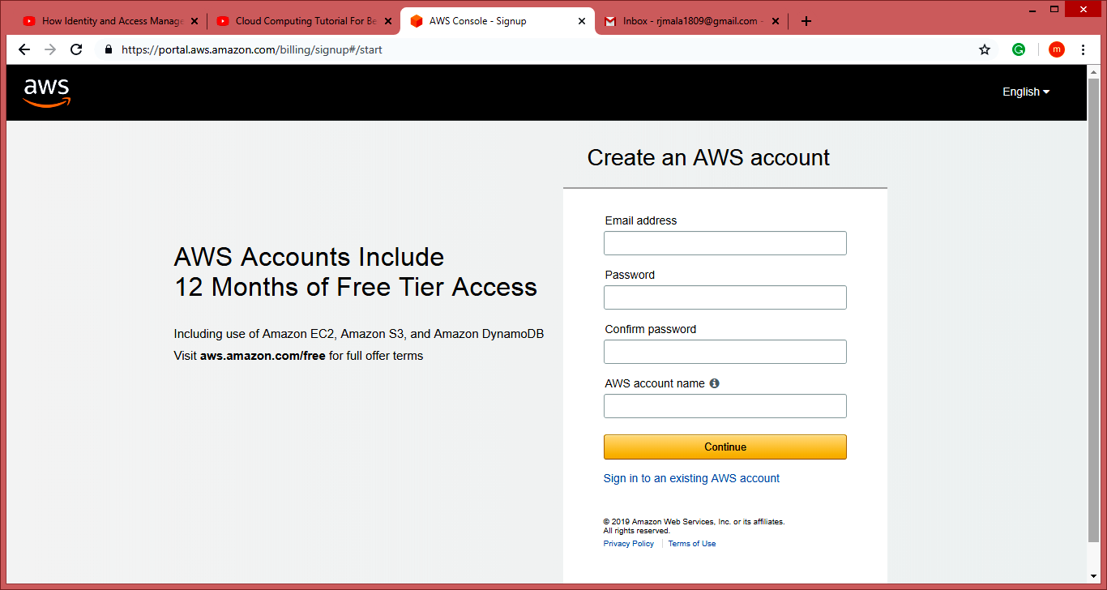

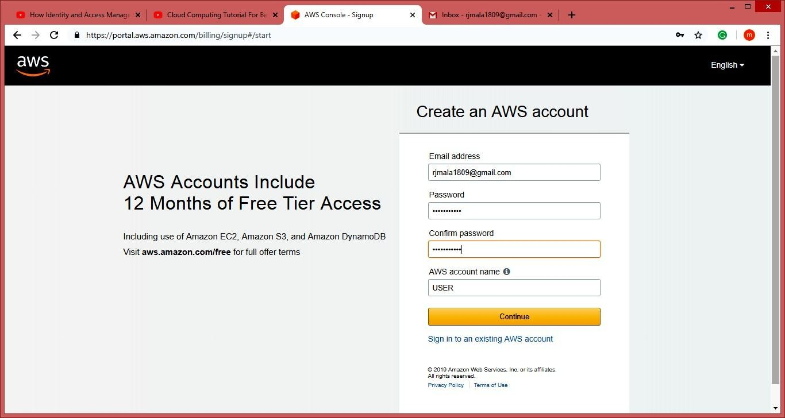

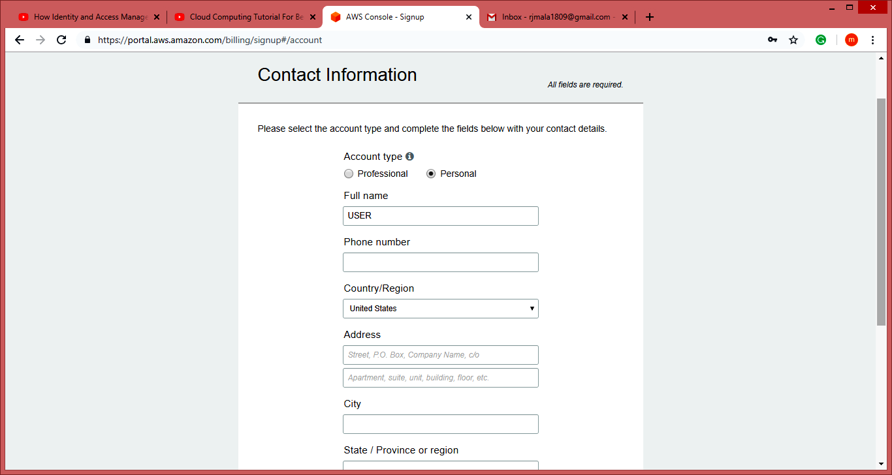

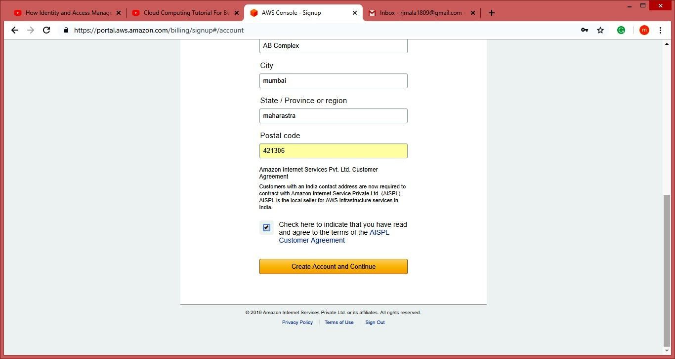

**NOTE:- Do not provide any kind of credit/debit card details or bank details.) Click on next**

##### Click on My Account, Select AWS Management Console.

**Enter your aws account userid and password click on sign in button**

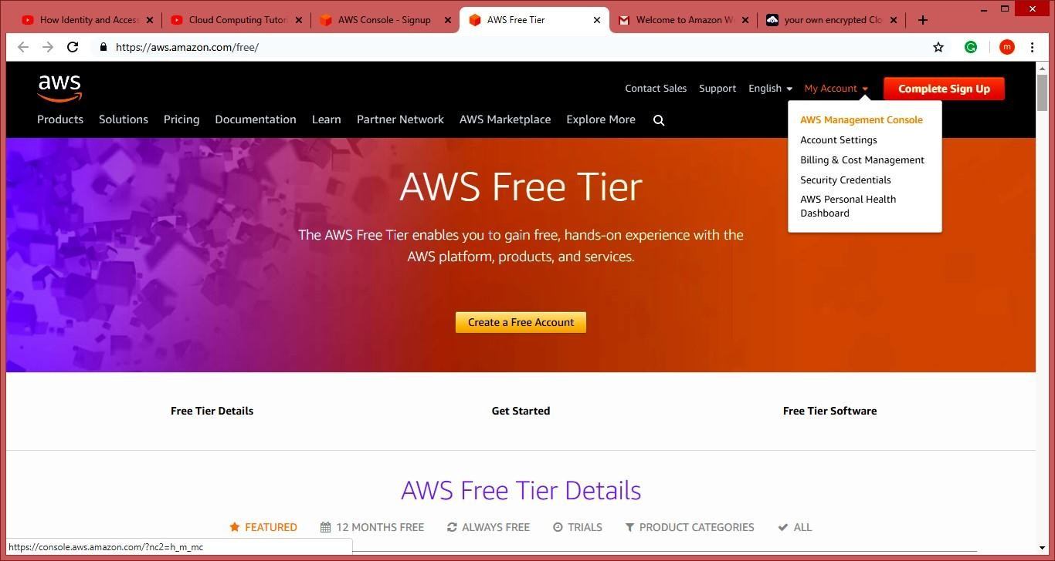

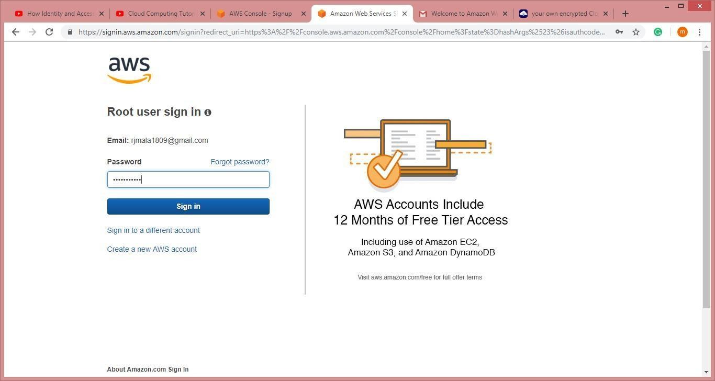

##### Now it will redirect you to home page without asking any other details. Now to we have to add user and group and assign them privilages.

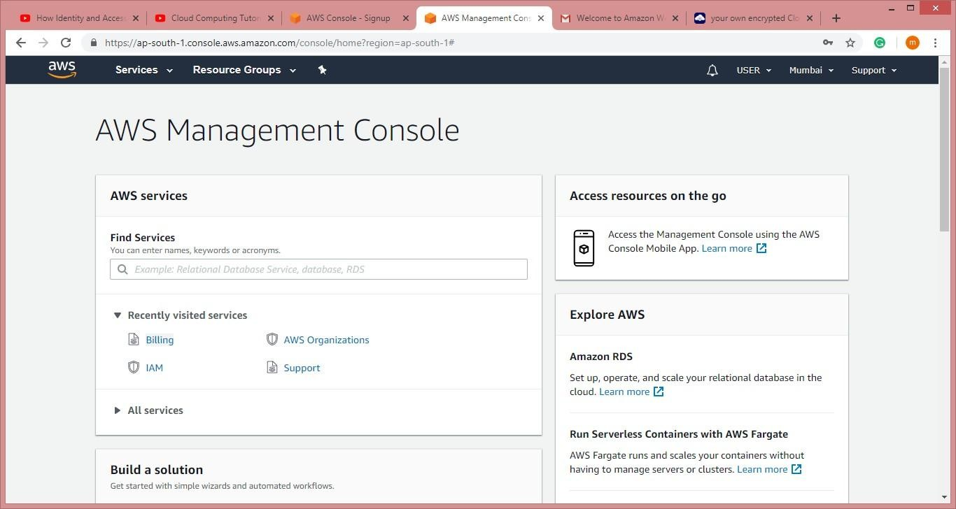

**Go to “My Security Credentials”. Click on “Users”.**

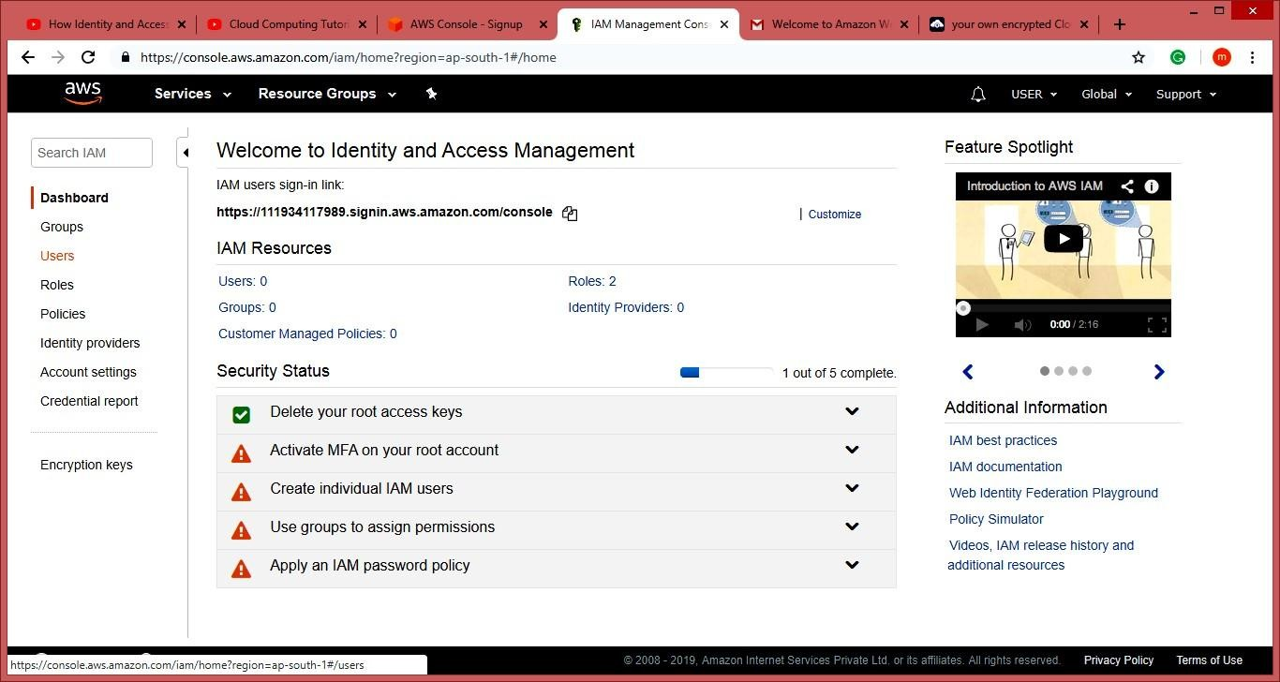

##### Click on “Add user”.

**Enter the name for the user. Check the check box in front of “Programmatic access” and “AWS Management Console access”.**

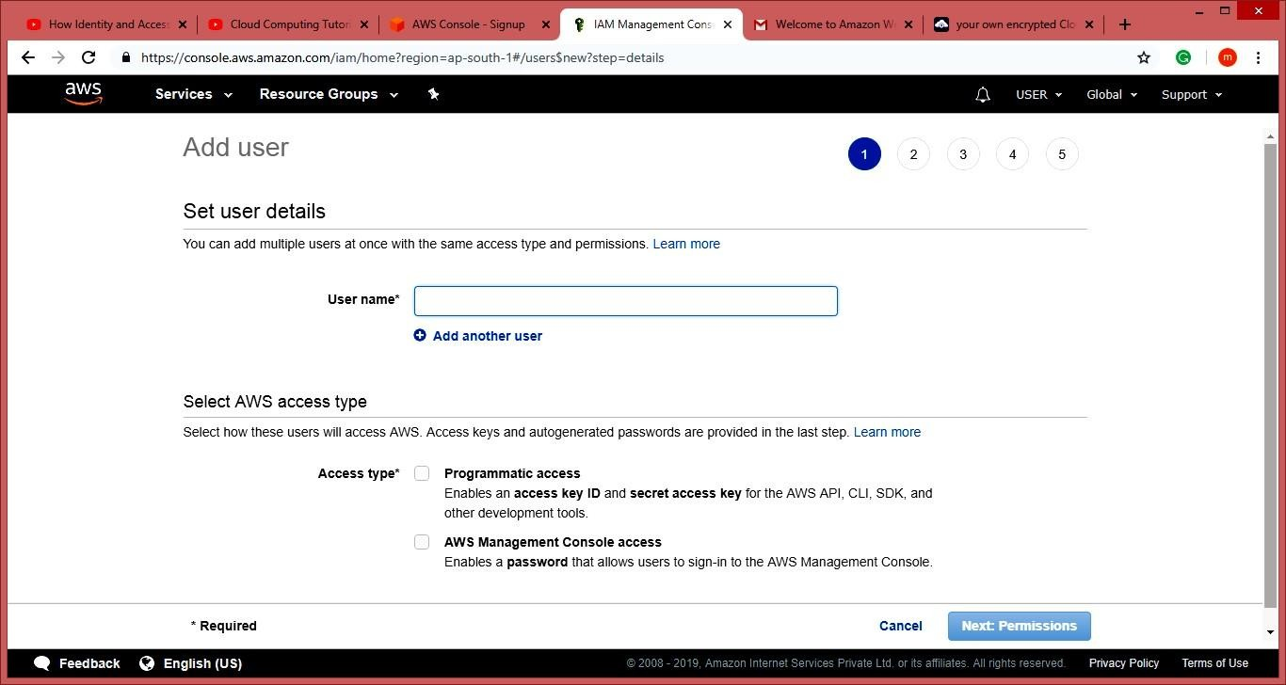

##### Scroll down and select “Custom password” and enter the password for the new user and click on “Next: Permissions”.

**Next**

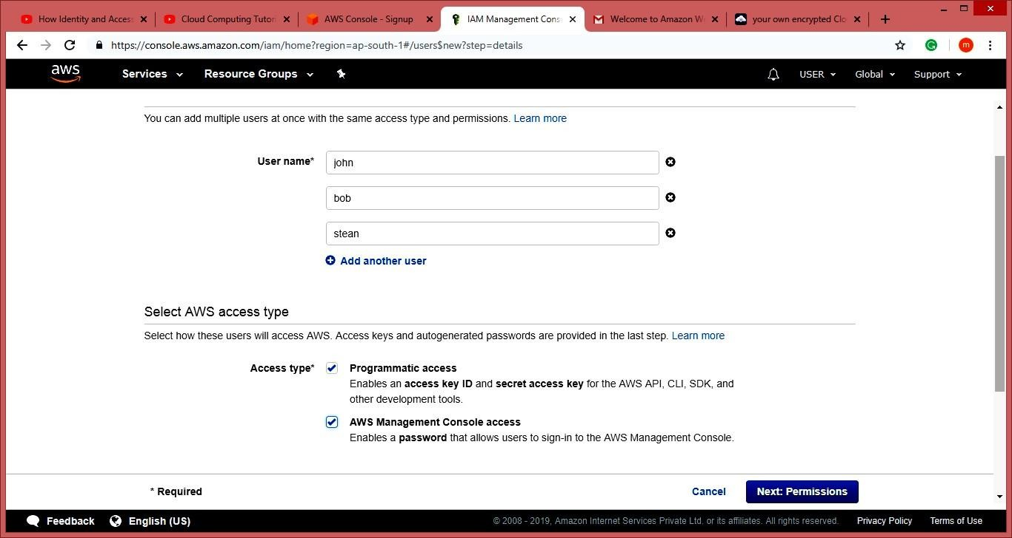

##### Next it allow you to create group or you can just pass it. We are going to create group click on “Create group”.

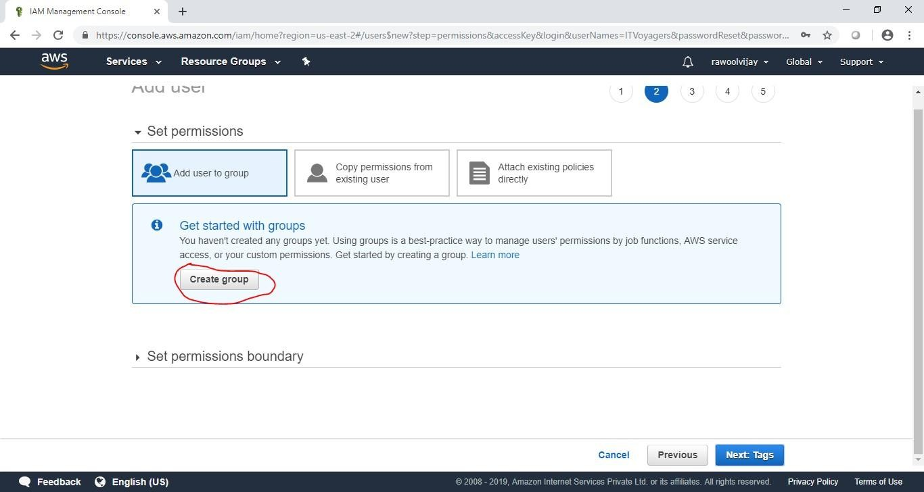

**Following window will appear.**

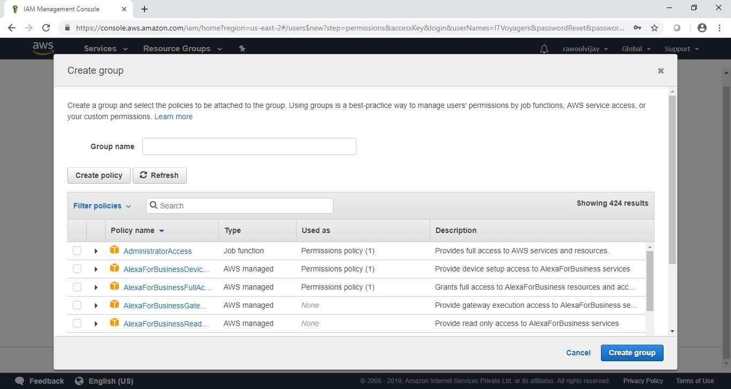

##### Give name to group, assign the their permissions and click on“Create group”.

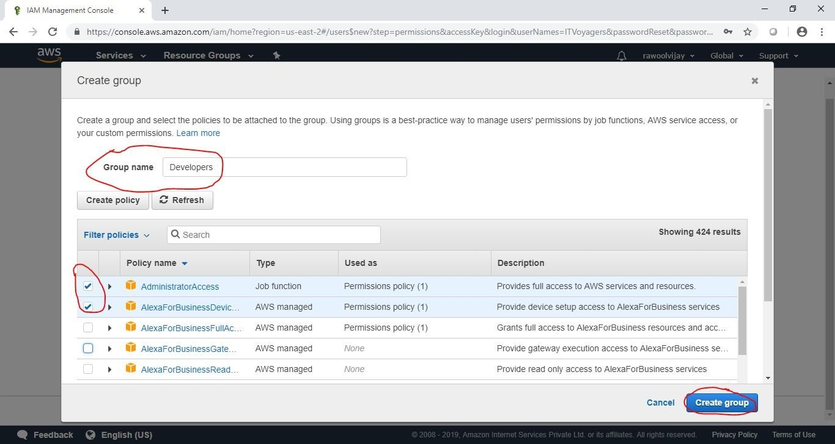

**Your group is created now click on “Next: Tags”.**

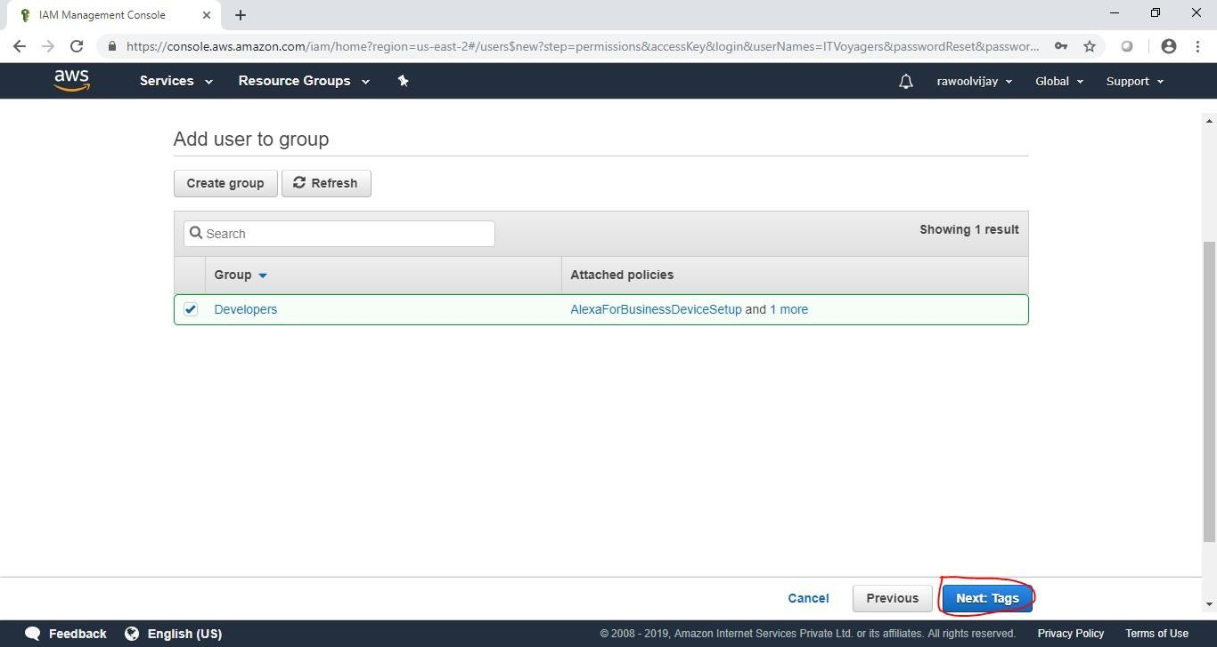

##### Click on “Next: Review”.

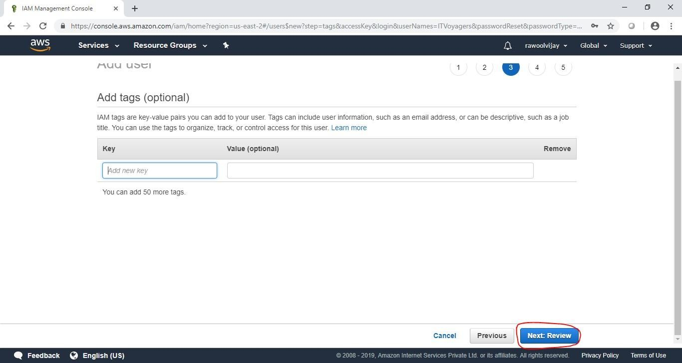

**Check the Review for the user and click on “Create user”.**

##### Click on

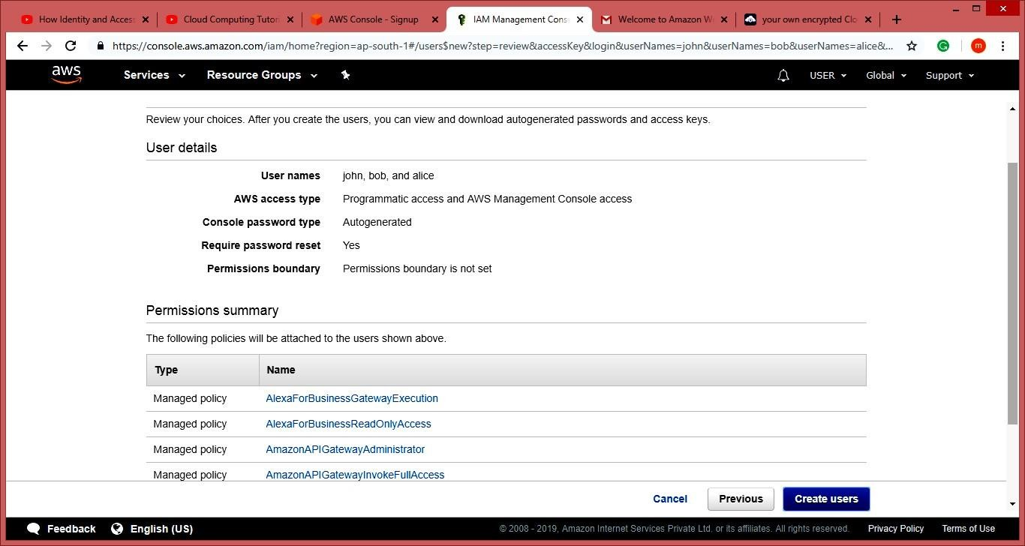

**Click on “Close”.**

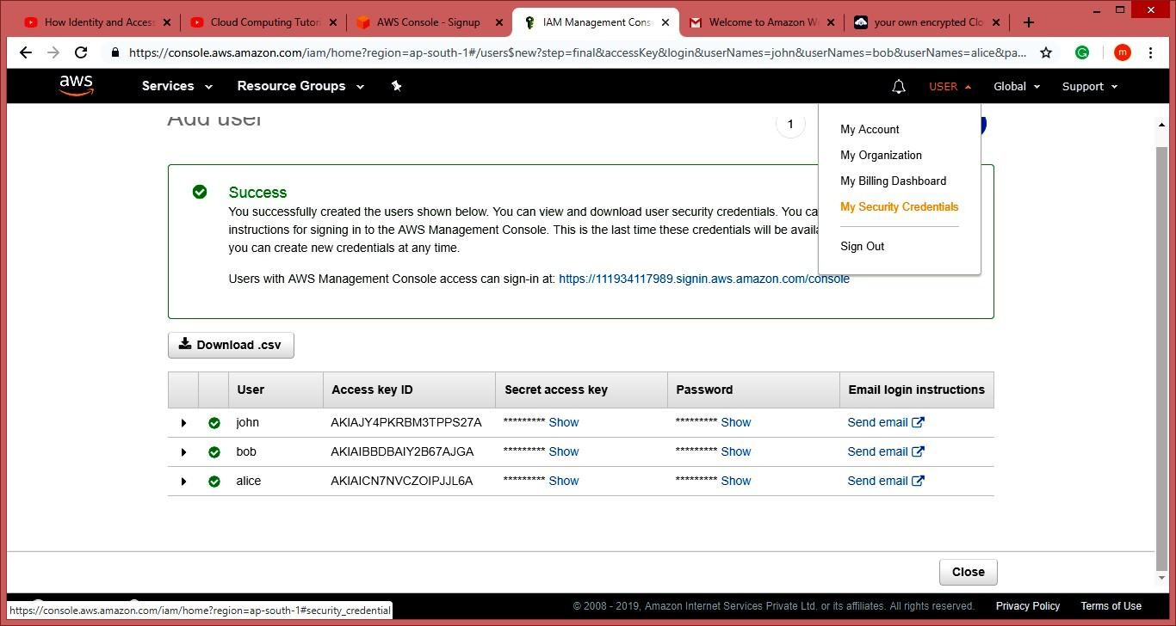

##### Click on “Group”. You will see the group you just created.



**Now log out of admin account and try to login as user (newly created).**

##### Navigate to link below. https://aws.amazon.com/console/

**Go to “My Account” > “AWS Management Console”.**





**It will ask you to change the password which is been set by administrator. You will be redirected to home screen.**



# Practical 6

### Aim: Study Cloud Security Management Description:

##### Ensure effective governance and compliance

Most organizations have security, privacy and compliance policies and procedures to protect their IP and assets. In addition to this, organizations should establish a formal governance framework that outlines chains of responsibility, authority and communication. This describes the roles and responsibilities of those involved, how they interact and communicate, and general rules and policies.

##### Audit operation and business processes

It is important to audit the compliance of IT system vendors that host the applications and data in the cloud. There are three important areas that need to be audited by cloud service customers: internal control environment of a cloud service provider, access to the corporate audit trail, and the cloud service facility’s security.

##### Manage people, roles, and identities

Using the cloud means there will be employees from the cloud service provider that can access the data and applications, as well as employees of the organization that perform operations on the providers system. Organizations must ensure that the provider has processes that govern who has access to customer data and application. The provider must allow the customer to assign and manage roles and authorization for each of their users. The provide must also have a secure system in place to managing the unique identifies for users and services.

##### Proper protection of data

Data is the core of all IT security concerns for any organization. Cloud computing does not change this concern but brings new challenges because of the nature of cloud computing.The security and protection of data both at rest and in transit needs to be ensured.

### Procedure:

**1:** Go to aws.amazon.com



**2:** Click On My Account.

**3:** Select aws management console and click on it.



**4:** Create AWS account(fill the required details)







##### NOTE:- Do not provide any kind of credit/debit card details or bank details.) 5: Click on next

(open your gmail check you will get message from amazon).

**6:** Click on My Account, Select AWS Management Console.

**7:** Enter your aws account userid and password click on sign in button





**8:** Click on Services tab



**9:** Click on Security, identity & Appliances Select IAM

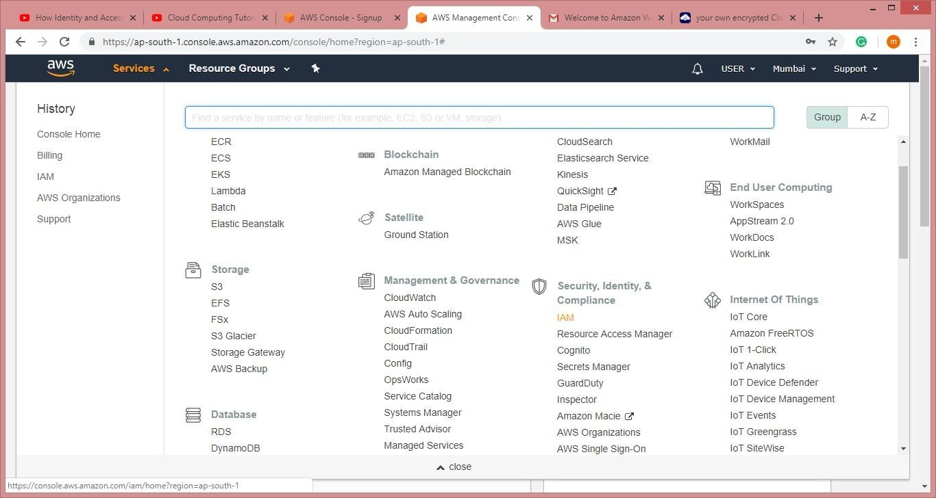

**10:** Click on Users From Dashboard



**11:** Click on Add User and Add the users.



**12:** Goto Select AWS access type check both the rediobutton. And click on next permission



**13:** Click on Attach Existing Policy Directly. Attach Policy to the users. And press Next Tab.

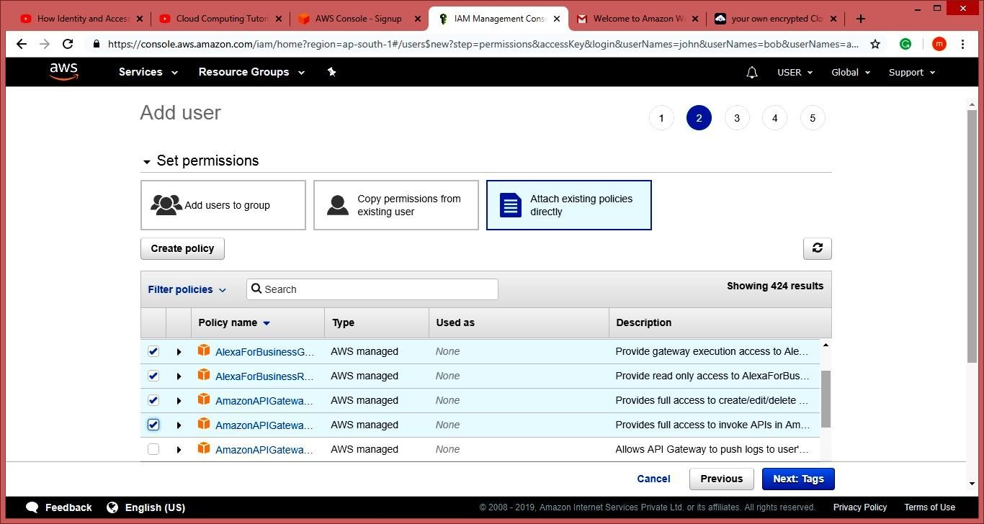

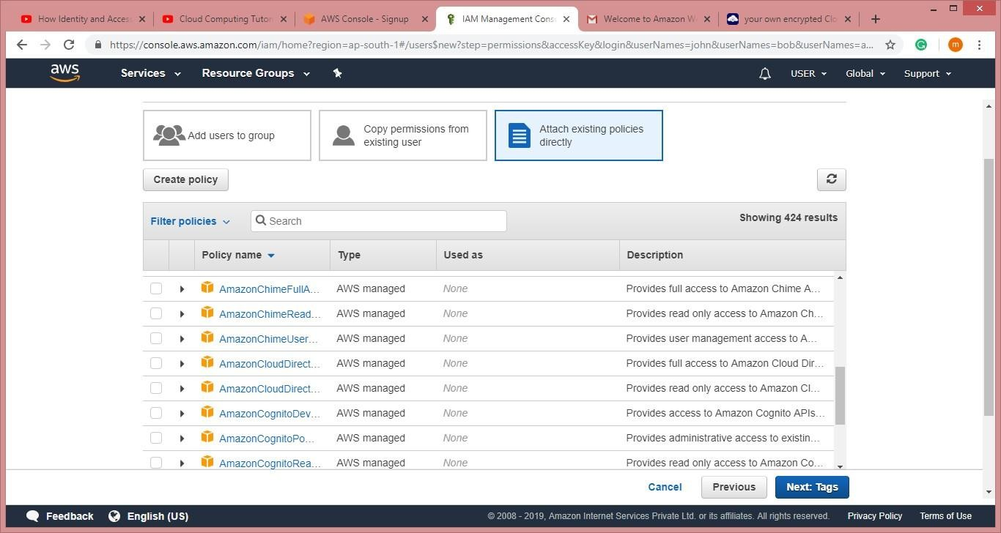

**14:** Click On Create User(Here Users are created.)



**15:** Now download the csvfile . and click on close.



**16:** Now Goto Account and select My Secuirity Credential tab > Click on Continew to security credentials .

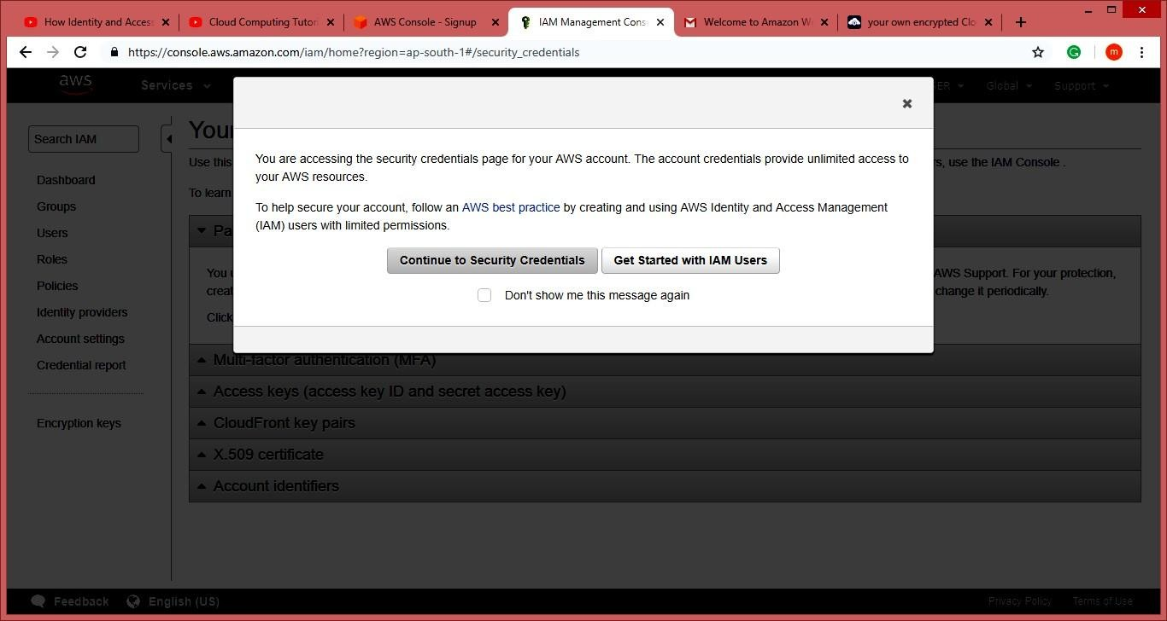

**17:** Click on Multi-factor authentication(MFA)

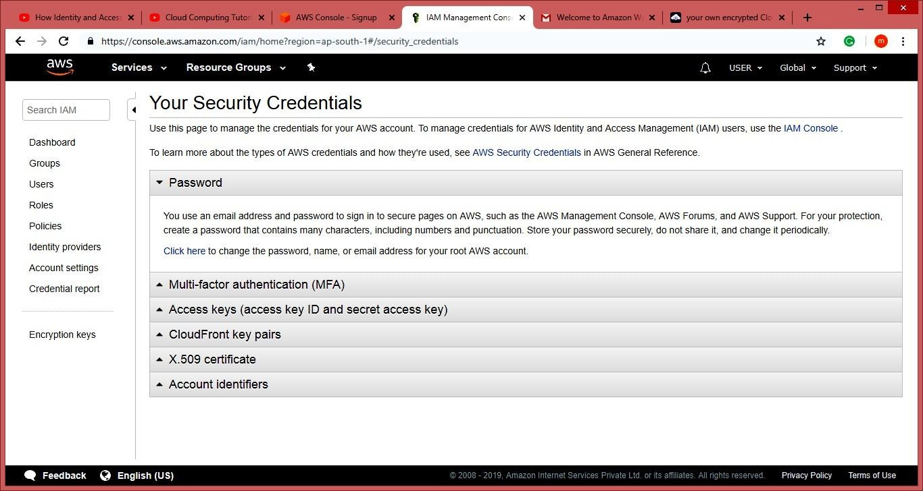

**18:** Click On Active MFA

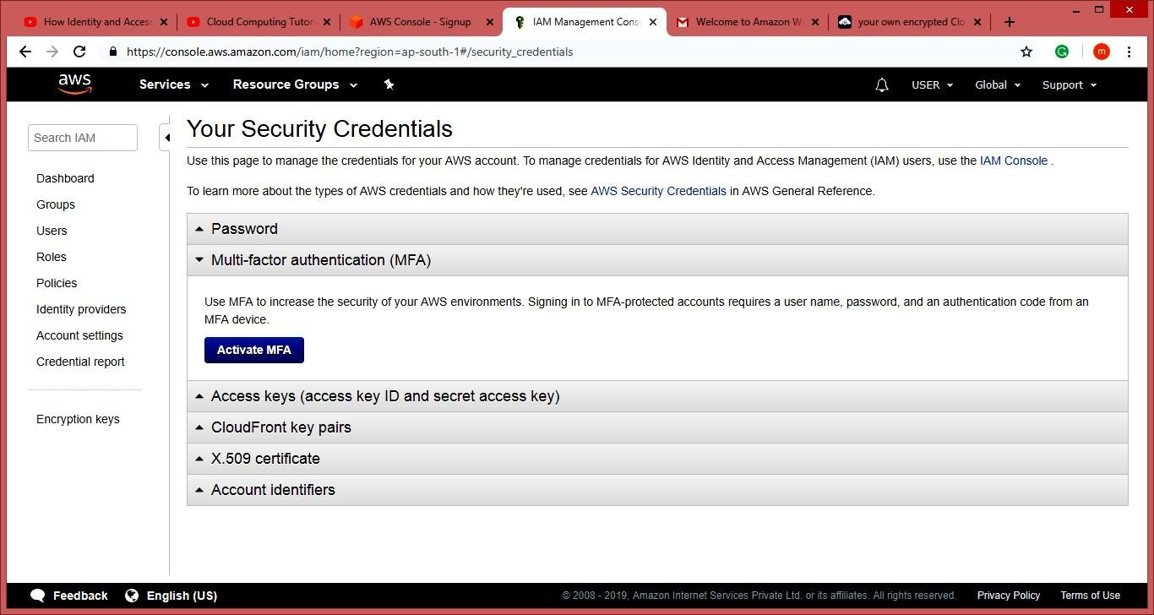

**19:** Select Virtual MFA device and Click on Continue tab

##### Note: Download Barcode Scanner and Google Authentication App in your Mobile Phone.

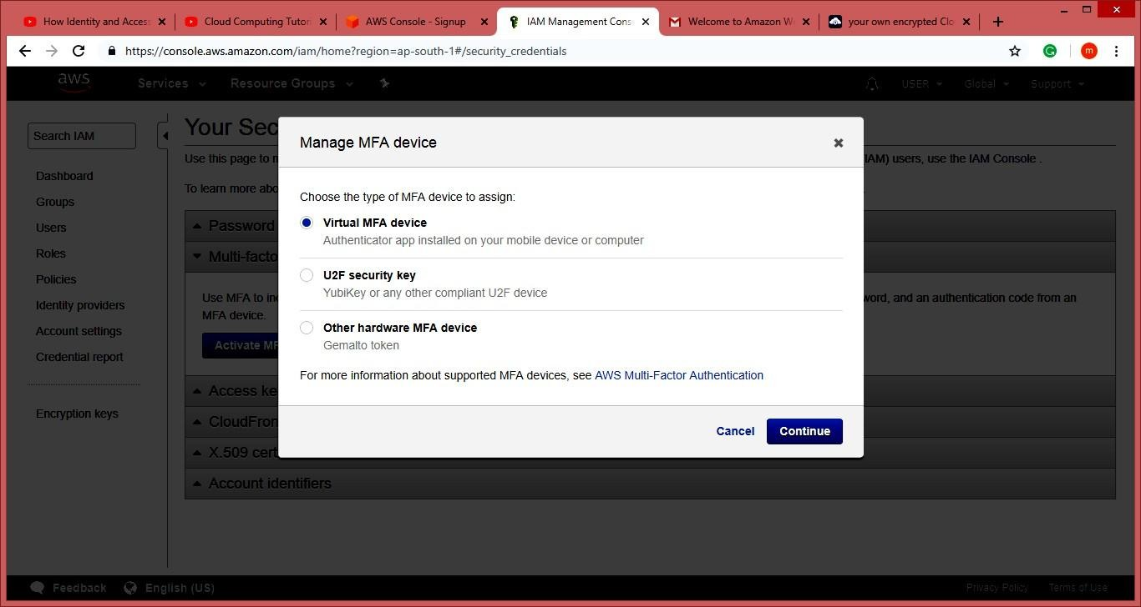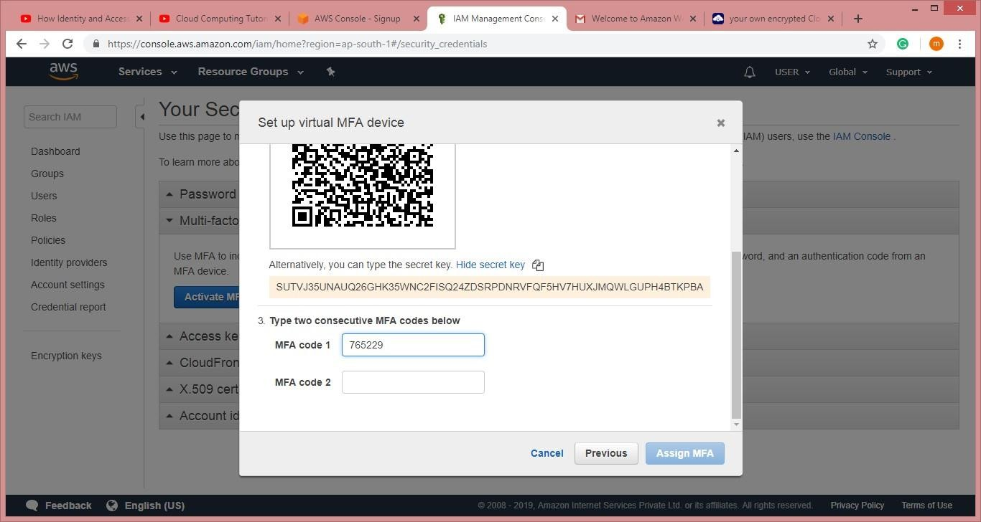

**20:** Scan the QR code and enter the MFA code from ur mobile phone and then click on assign Assign MFA tab

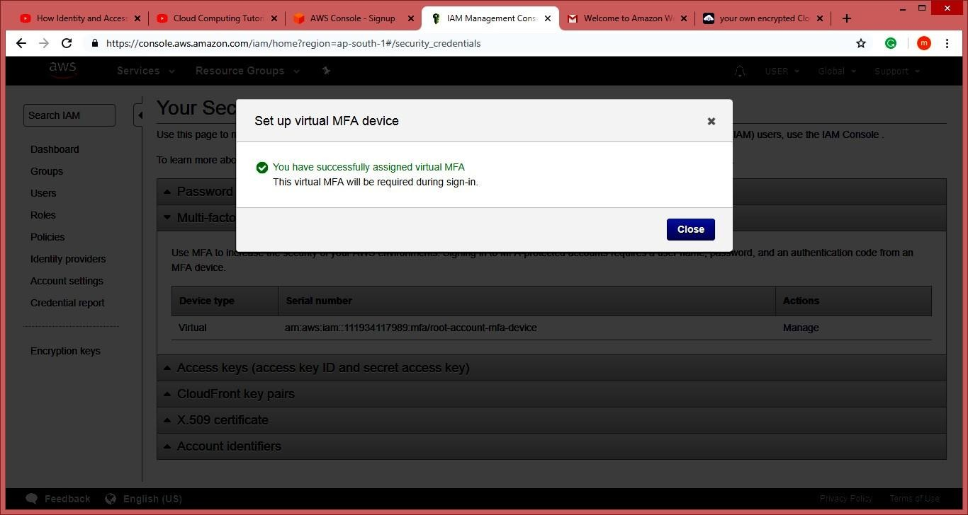

**21:** Now the page look like this.

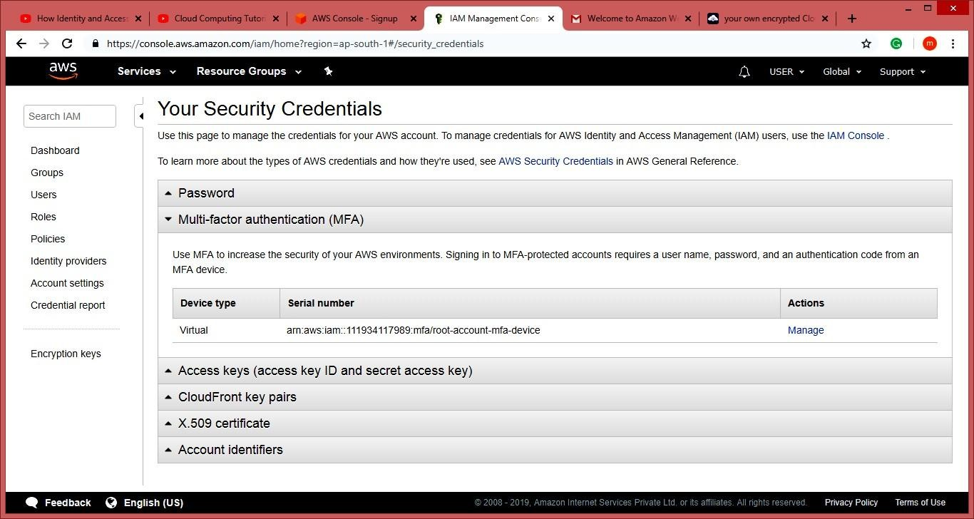

**22:** Click On Dashboard Go to Additional Information Select Policy Simulator

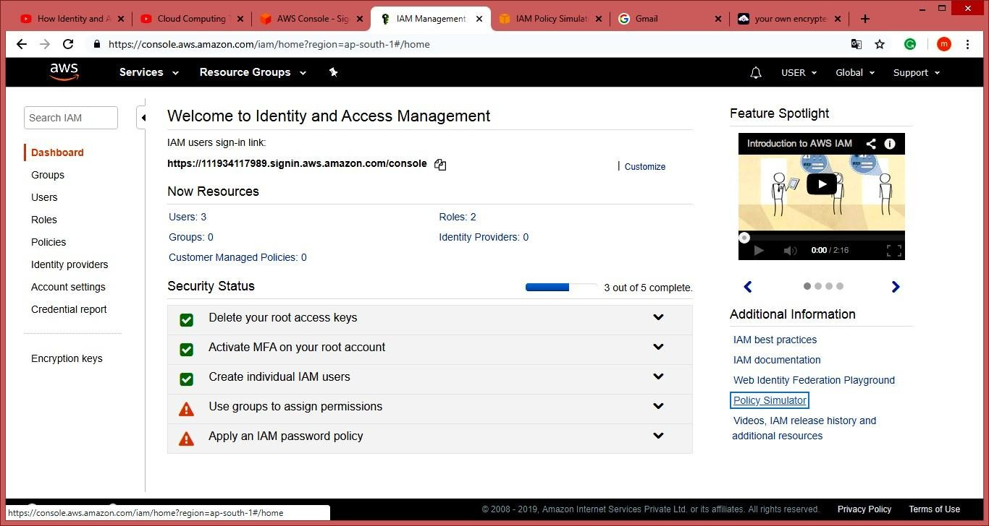

**23:** Select The User select services and service action and click on Run Simulator Tab

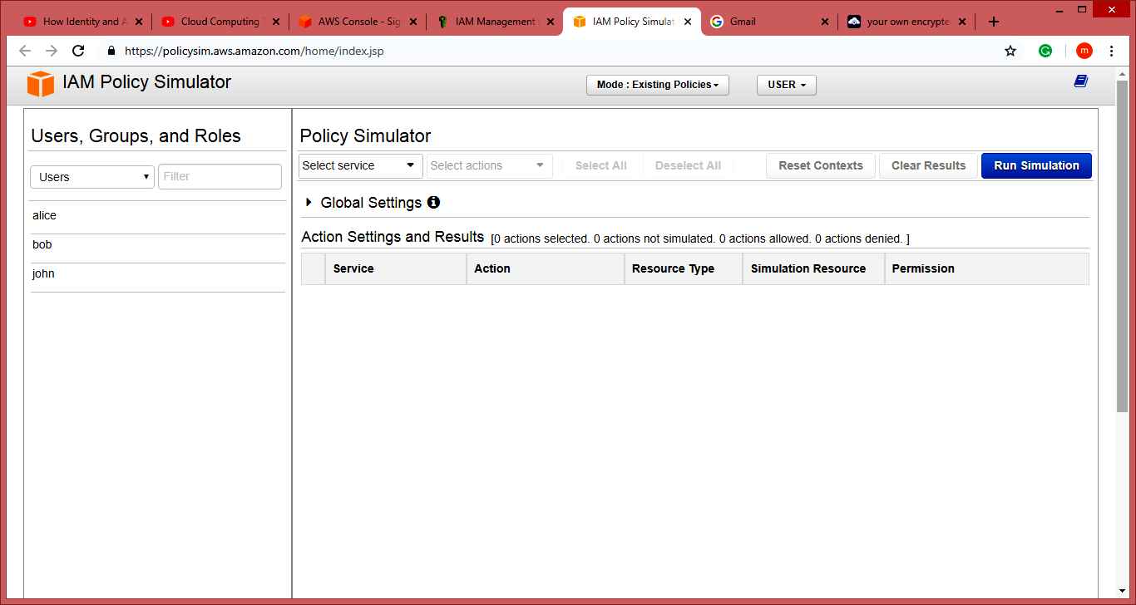

# Practical-7

### Aim: Write a program for web feed. Description:

RSS (originally RDF Site Summary; later, two competing approaches emerged, which used the backronyms Rich Site Summary and Really Simple Syndication respectively)[2] is a type of web feed[3] which allows users and applications to access updates to online content in a standardized, computer-readable format. These feeds can, for example, allow a user to keep track of many different websites in a single news aggregator. The news aggregator will automatically check the RSS feed for new content, allowing the content to be automatically passed from website to website or from website to user. This passing of content is called web syndication.

Websites usually use RSS feeds to publish frequently updated information, such as blog entries, news headlines, or episodes of audio and video series. RSS is also used to distribute podcasts. An RSS document (called "feed", "web feed",[4] or "channel") includes full or summarized text, and metadata, like publishing date and author's name.

A standard XML file format ensures compatibility with many different machines/programs. RSS feeds also benefit users who want to receive timely updates from favourite websites or to aggregate data from many sites.

Subscribing to a website RSS removes the need for the user to manually check the website for new content. Instead, their browser constantly monitors the site and informs the user of any updates. The browser can also be commanded to automatically download the new data for the user.

### Procedure:

##### 1: Open Notepad File Type the following Code and save it as rss.xml extension.

<?xml version="1.0" encoding="UTF-8"?>

<rss version="2.0">

<channel>

<title>W3Schools Home Page</title>

<link>https:/[/www.w3schools.com](http://www.w3schools.com/)</link>

<description>Free web building tutorials</description>

<item>

<title>RSS Tutorial</title>

<link>https:/[/www.w3schools.com/xml/xml_rss.asp](http://www.w3schools.com/xml/xml_rss.asp)</link>

<description>New RSS tutorial on W3Schools</description>

</item>

<item>

<title>XML Tutorial</title>

<link>https:/[/www.w3schools.com/xml<](http://www.w3schools.com/xml)/link>

<description>New XML tutorial on W3Schools</description>

</item>

</channel>

</rss>

##### 2: Open the software visual studio 2010 Do the following

**File -> New -> Website-> visual C# -> ASP.NET website -> OK**

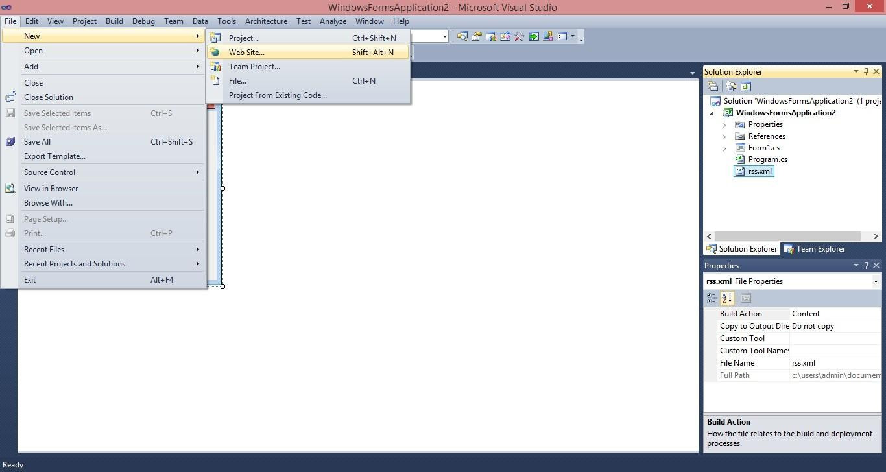

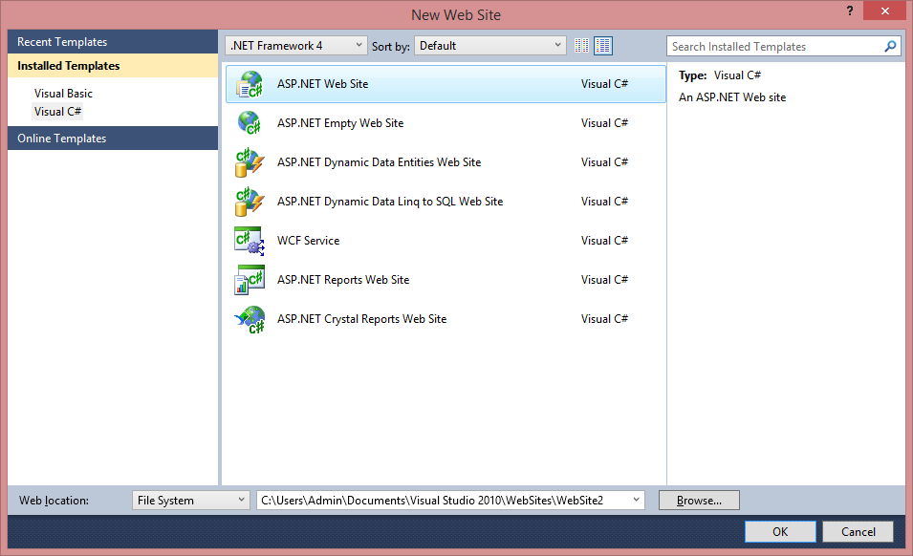

##### 3: Now copy that rss file which was saved with .xml extention inside your website folder.

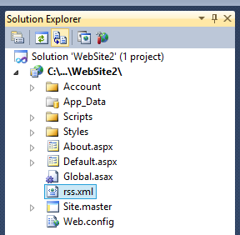

Rss.xml

**4: Type this in default.aspx**

##### <p>here is ur <a href="rss.xml">feed</a>.</p>

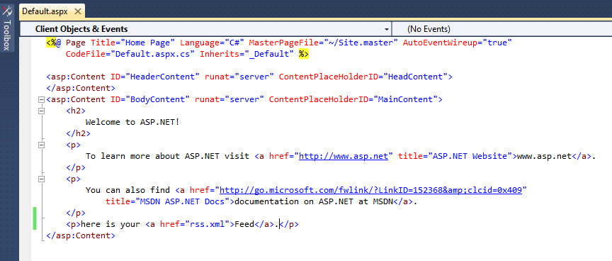

**5: Run**

**the page**

**6: output**

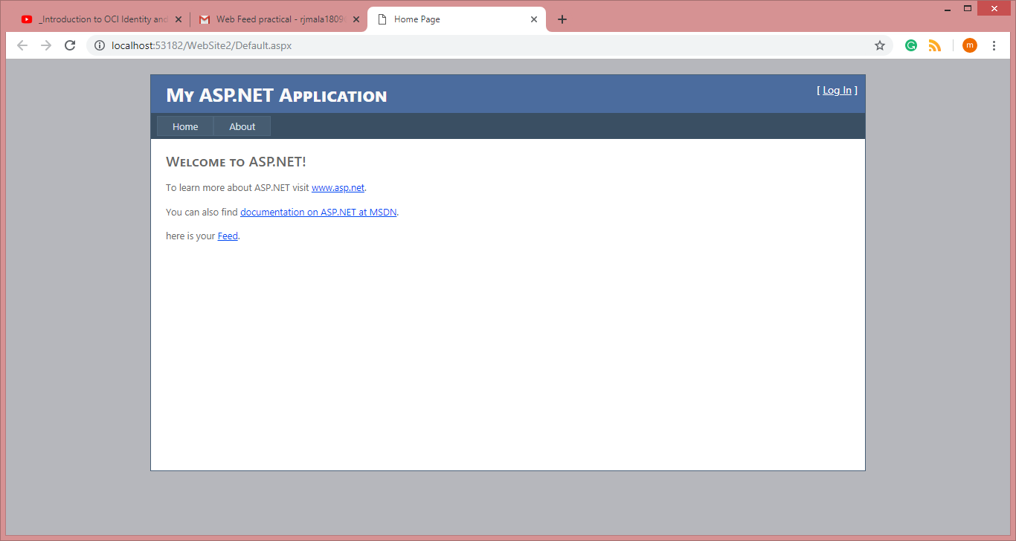

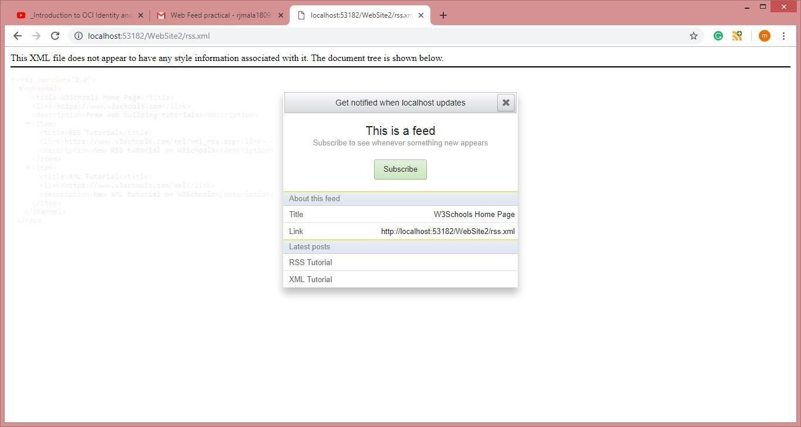

# Practical -8

### Aim: Study and implementation of Single-Sign-On Description:

Single sign-on (SSO) is a session and user authentication service that permits a user to use one set of login credentials (e.g., name and password) to access multiple applications. The service authenticates the end user for all the applications the user has been given rights to and eliminates further prompts when the user switches applications during the same session. On the back end, SSO is helpful for logging user activities as well as monitoring user accounts.

In a basic web SSO service, an agent module on the application server retrieves the specific authentication credentials for an individual user from a dedicated SSO policy server, while authenticating the user against a user repository such as a lightweight directory access protocol (LDAP) directory.

Some SSO services use protocols such as Kerberos and the security assertion markup language (SAML). SAML is an XML standard that facilitates the exchange of user authentication and authorization data across secure domains. SAML-based SSO services involve communications between the user, an identity provider that maintains a user directory, and a service provider. When a user attempts to access an application from the service provider, the service provider will send a request to the identity provider for authentication. The service provider will then verify the authentication and log the user in. The user will not have to log in again for the rest of his session. In a Kerberos-based setup, once the user credentials are provided, a ticket-granting ticket (TGT) is issued. The TGT fetches service tickets for other applications the user wishes to access, without asking the user to re-enter credentials.

Although single sign-on is a convenience to users, it present risks to enterprise security.

An attacker who gains control over a user's SSO credentials will be granted access to every application the user has rights to, increasing the amount of potential damage. In order to avoid malicious access, it's essential that every aspect of SSO implementation be coupled with identity governance. Organizations can also use two factor authentication (2FA) or multifactor authentication (MFA) with SSO to improve security.

### Procedure:

**1:** Open chrome->go to the URL-> <https://auth0.com/learn/how-to-implement-single-sign-on/>

And this page will appear

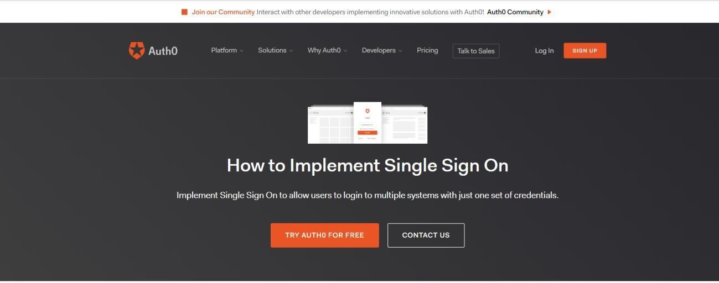

**2:** Click on **TRY AUTH FOR FREE ->** now sign up -> provide user name(Click on next)->select 1-account type(personal)

1. Role(Non developer)
2. Project(just playing around)

**3**: Click on CREATE ACCOUNT->Dashboard will appear

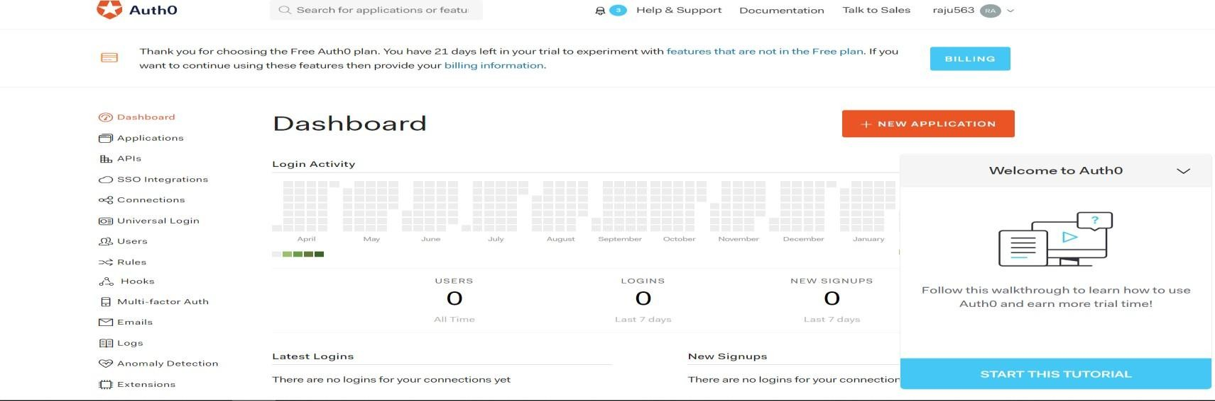

**4:** Click on Connection-> select (**Social**)-> click on google try as shown in Image

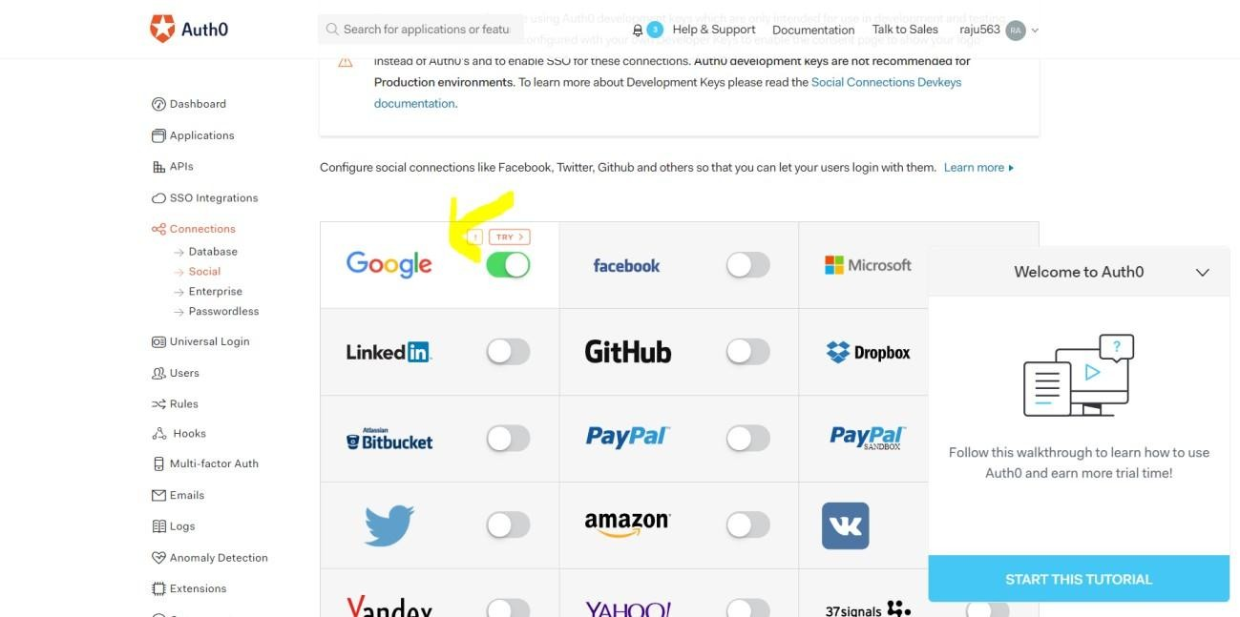

**Sign in with same account n you will get this output.**

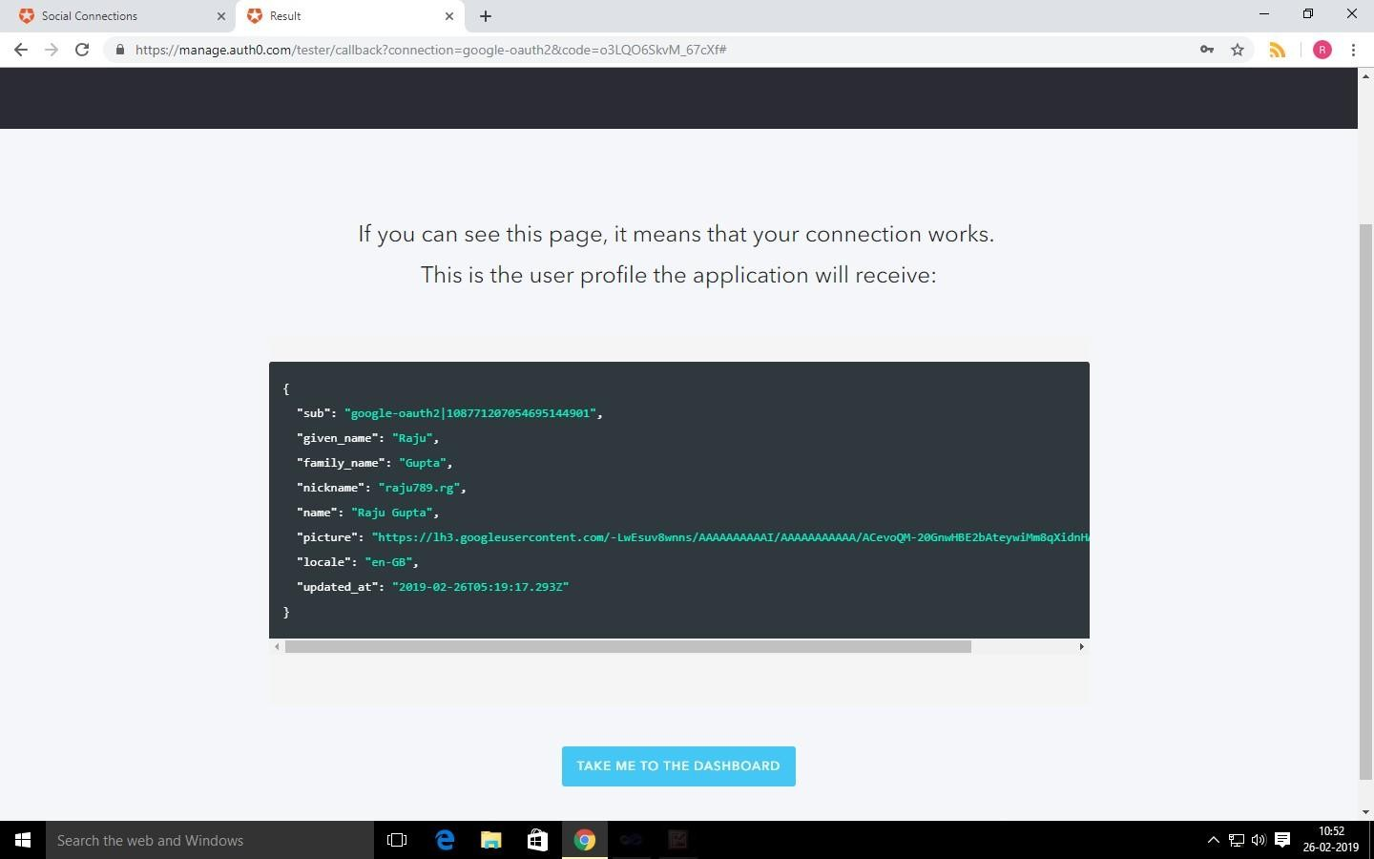

# Practical -9

### Aim: User management in cloud. Description:

User management describes the ability for administrators to manage user access to various IT resources like systems, devices, applications, storage systems, networks, SaaS services, and more. User management is a core part to any directory service and is a basic security essential for any organization. User management enables admins to control user access and on-board and off-board users to and from IT resources. Subsequently a directory service will then authenticate, authorize, and audit user access to IT resources based on what the IT admin had dictated. Traditionally, user management has been grounded with on-prem servers, databases, and closed virtual private networks (VPN). However, recent trends are seeing a shift towards cloud-based identity and access management (IAM), granting administrators even greater control over digital assets.

### Procedure:

##### 1: Adding a user on ubuntu

sudo adduser rjcs

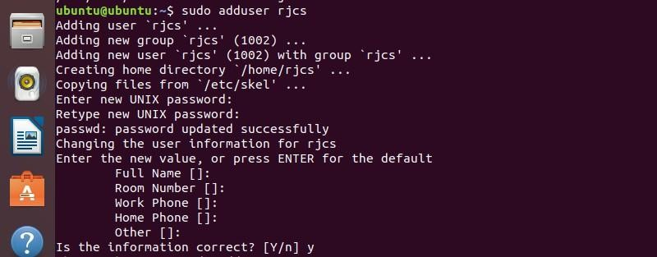

##### To Add a system user rjcs run the ollowing cammand



Login as rjcs user by using following cammand



##### 2: Adding a group on ubuntu

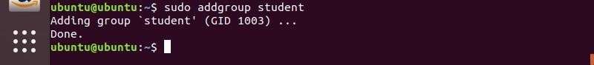

**3: Adding a User to a group on ubuntu**



You can login as a rjcs and run the following command.



##### 4: Removing the user from a group on ubuntu

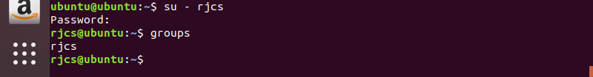

**5: Removing a user on ubuntu**

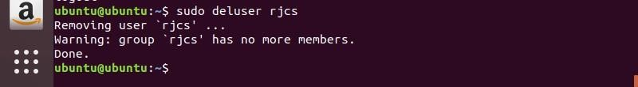

##### 6: Deleting a group on ubuntu

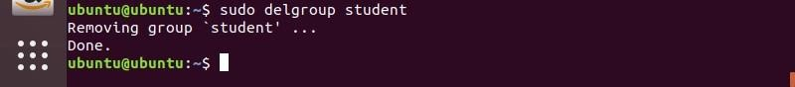

**7: Listing all the users on ubuntu**

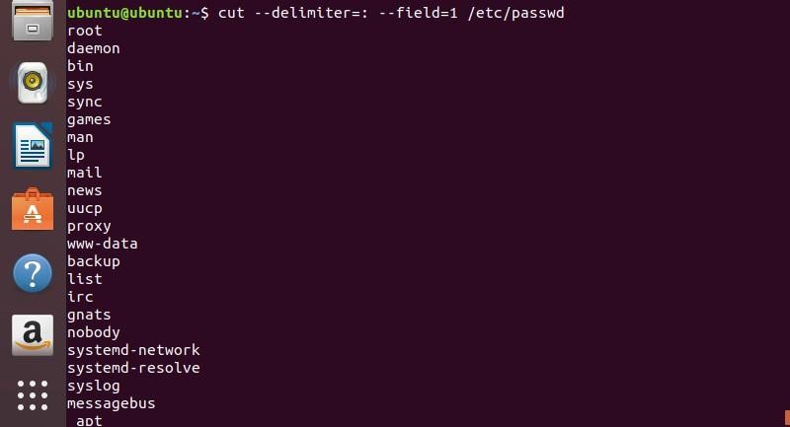

##### 8: Listing all the groups on ubuntu

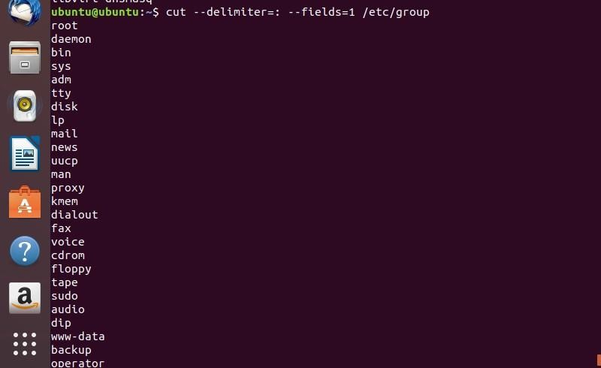

**9: Listing all the user in a group on ubuntu**

